**<http://test2live.com/bettingtime/admin/>**

Korean word 2~10

10. 해외스포츠배팅사이트

9. 안전한놀이터추천함

8. 안전한놀이터추천

7. 해외배팅사이트

6. 안전한놀이터

5. 안전놀이터

4. 해외토토

3. 놀이터

2. 안전

so even you lose, just search by "korean word"

**http://test2live.com/bettingtime/Request modify list**

**1.** **Social Icon(DONE)**

- I would like to go directly link if I click any of them except “chat “.

- After click any of icon, remaining color like right image. Please fix it.



**2.** **Login(DONE)**

- It also same happening like above that remaining clicked effect.

- And something not enough for Login layout. Will talk together about it later.



**3.** **Sport recommendation(DONE)**

- Sport recommendation text (header), please make it same line with below site name. Move header text to left little bit more please.

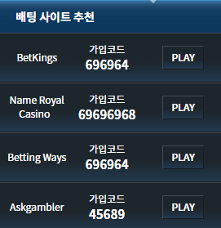

**4.** **Login&register UI**

- From my laptop, when I click register page at fisrt, it was okay. I could scroll easily but from login ui and if I click “sign up” I could not see 2 buttons like below image. And before, I could not see close button. It was hided. There are errors.

- From login page, “**Forgot password**” button, please make it more space between up and down. It seems too close with sign in button.

- And “SIGN IN” button, you need to move to left to make it same line with above lines like “SIGN UP”.

- After sign up, I would like to display pop-up message like” **congratulation! Your account has been created successfully. To continue using site, please verify your e-mail.**” And people could not received the mail. So we need a re-send mail button. I think we just better to make it verify from register page before click sign up button. And after clicking re-send e-mail button, need to display text again like **“If you didn’t get any e-mail, please contact to admin”**

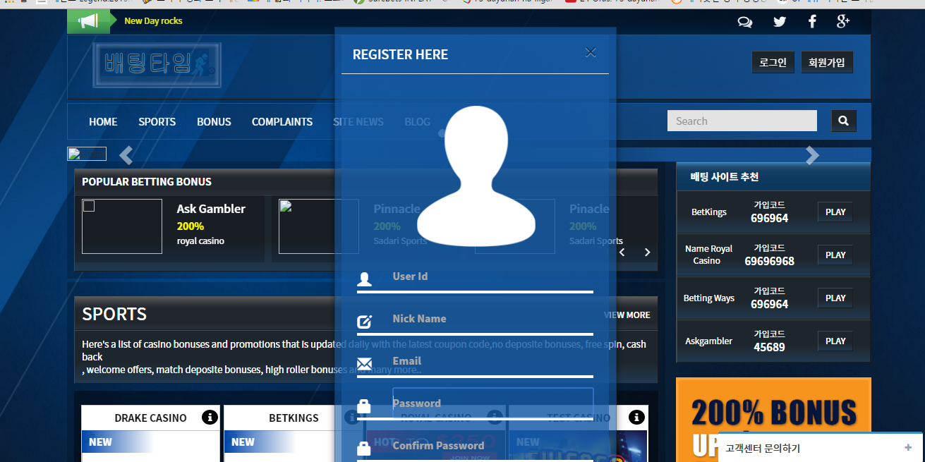

- And, I clicked “**sign in button**” without any typing and I closed . after that, I clicked popular bonus and it showed like below image. “**ERROR – Please fill Your User Id” (DONE)**

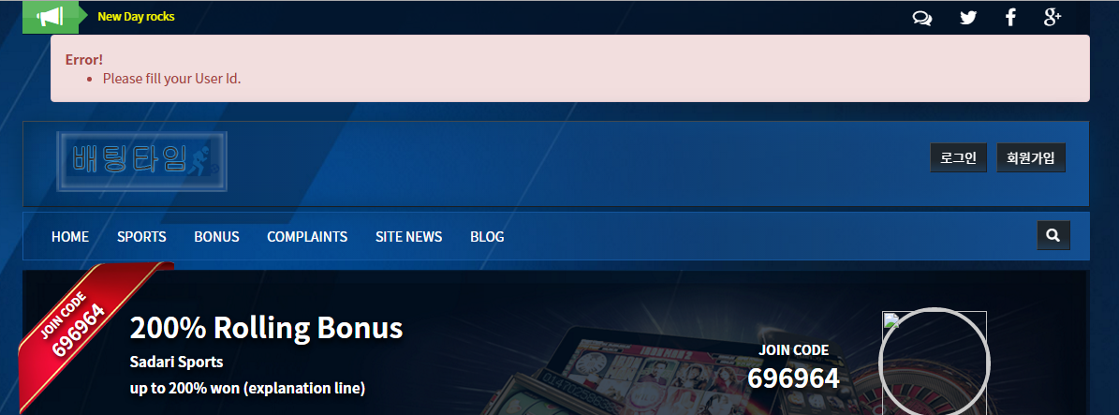

**5.** **Card Back side (Sport) (DONE)**

- First image is from Main page and Second image is from Online Sport category. Please make it like second image. reduce font size and make all single lines.. For last, When there is more than 1 “MINI GAME”, then put “ … “ or “ .etc “ to make it arrange.

* Please modify **SADARI SPORT**” togethe

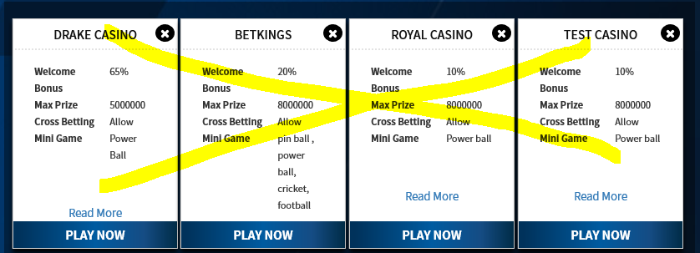

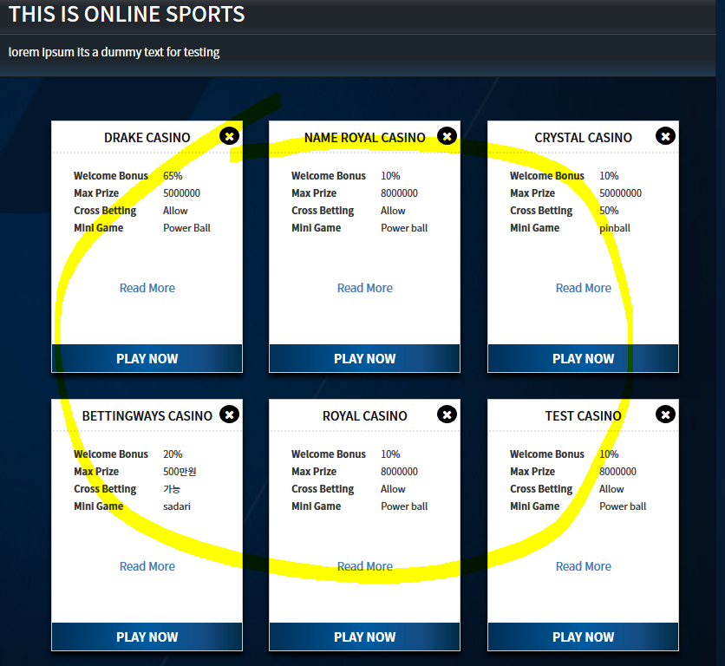

**5.** **Card Back side (Sports, sadari sports, news, bonus, blog) (DONE)**

- First image is from Main page and Second image is from Online Sport category. Please make it like second image. reduce font size and make all single lines.. For last, When there is more than 1 “MINI GAME”, then put “ … “ or “ .etc “ to make it arrange.

**6.** **Other card back side.**

- Please fix even other cards back side such as sadari sports,bonus card, complaint, etc all. Need to arrange.

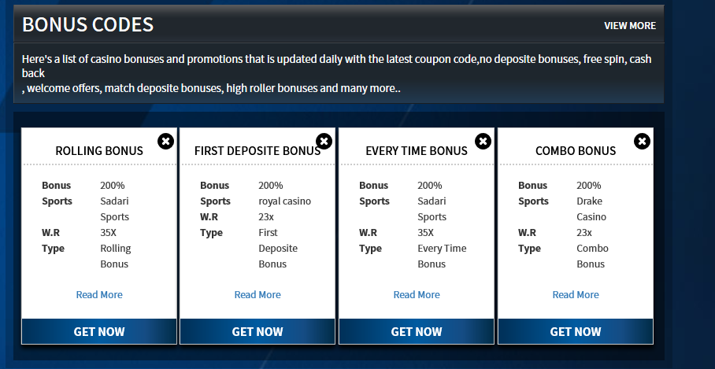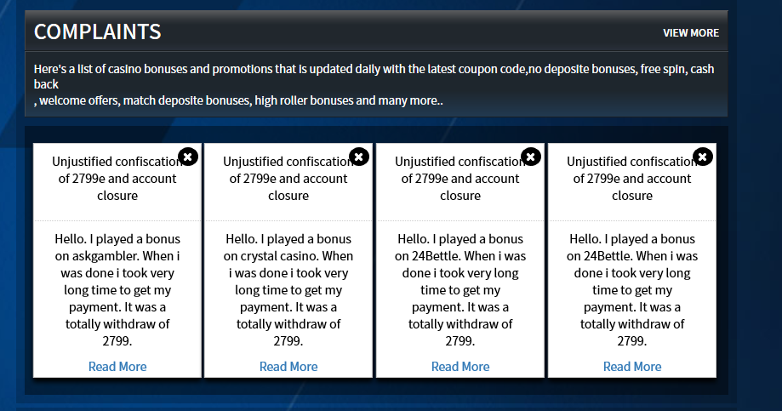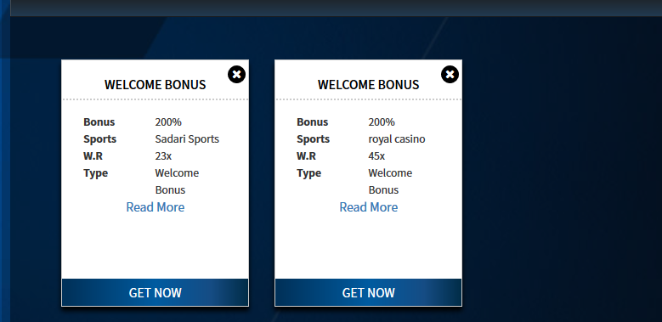

**7.** **Make it clickable please.(DONE)**

- I marked by yellow sign pen. please make it clickable all.

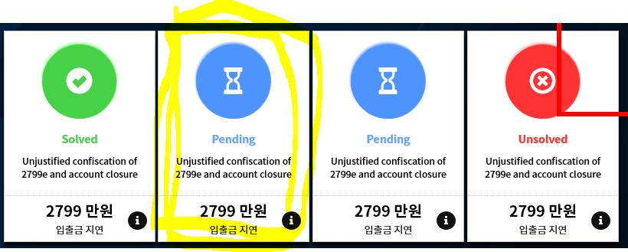

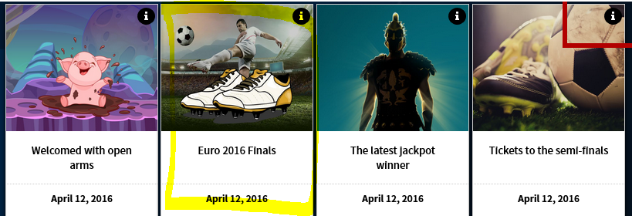

**8.** **Update footer please.**

- You can check from another share doc for that. for now, don’t have to make it direct link. you can update it first.

**9.** **Slider issue (DONE)**

- If there are only 4 sliders, then please show only 4 dot. it showing 6 at the moment even have only 4.



**10.** **Sport category page.(DONE)**

- When i check card back side from sport category, it sems smaller font than main page card back side. please try to make it bigger font.

In listing page card is bigger then main page card that is why fonts are looking little small

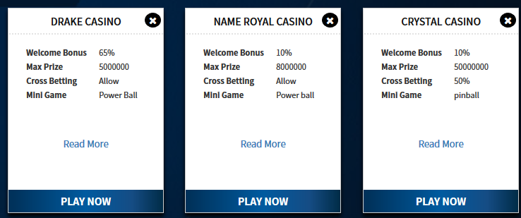

**11.** **Detail page issue.(DONE)**

- When i scroll to down, it seems not balance . so please reduce size until where i drowed by red pen.

**- 2016-09-01 update : please update JOINCODE beside site name**.(DONE)

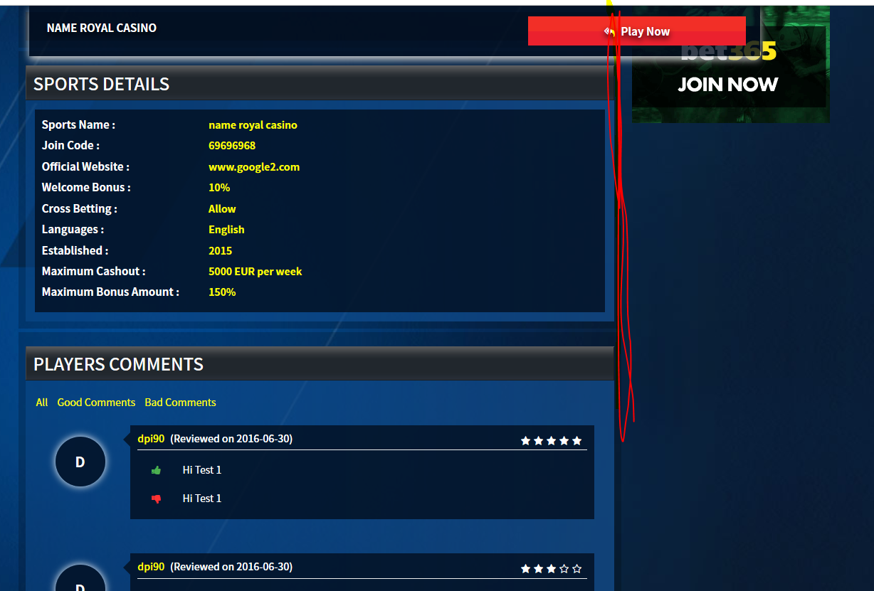

**12.** **submit Complaint issue.**

- Sub categories? please choose different color with background. (ex, 입금/출금 ).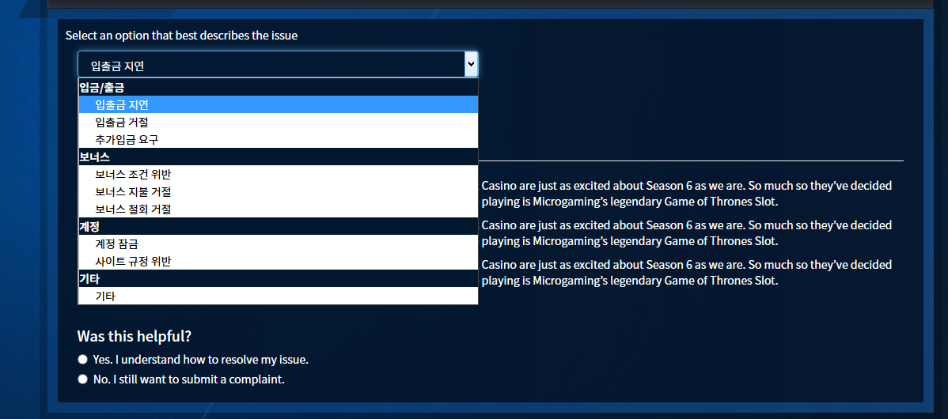

**13.** **RATE ERROR(DONE)**

- When i saw this at first, it was 5 start and 5 but even i click 2 , as you can see from below. it keep showing 5.

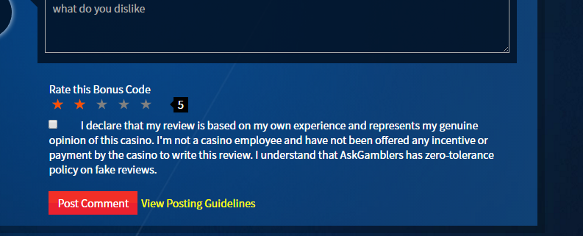

**14.** **VIEW MORE ERROR(DONE)**

- When i clicked view more, it went back to main page. it must be showed those 3 cards from different page.

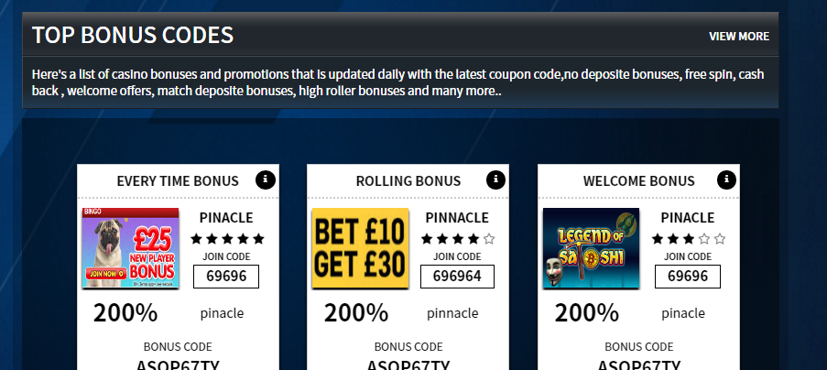

**15.** **Read more issue.(DONE) FOR BONUS CARDS,NEWS AND BLOGS**

- It seems too close with content. please modify and arrange it .(actually need to check all cards back side)

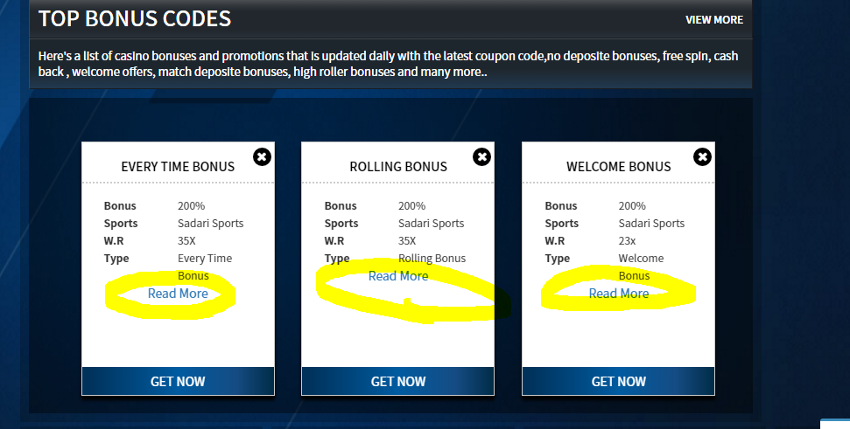

**16.** **If no comment..(DONE)**

- If no comment anything from detail page, display only test without buttons such as all, good comments, bad comments.

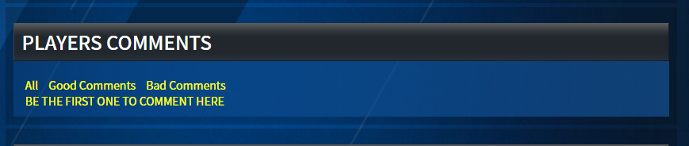

**17.** **Serach function.(DONE)**

- When i change page, it showing suddenly and gone. please check this. i would like to hide before until clicking search button.

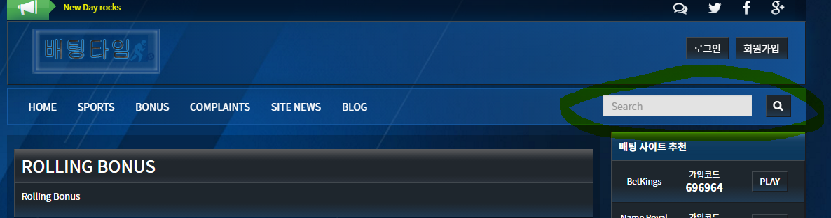

**18.** **Please update real number of submit posts(DONE)**

-

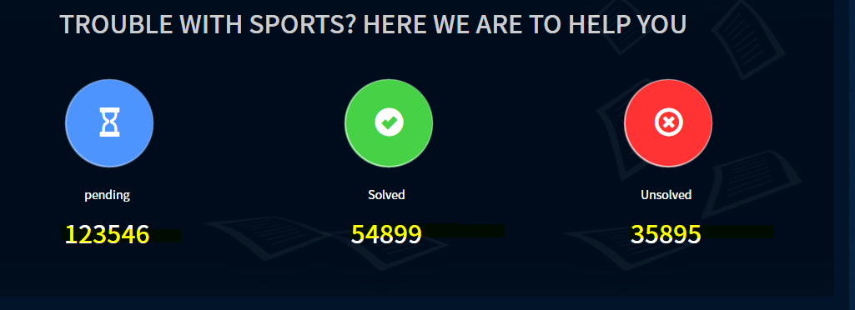

**19.** **Complain page.(DONE)**

- From complain page, move that button to below. that button is hided text.

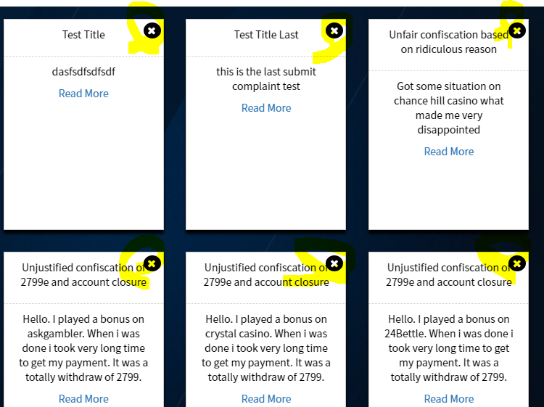

**20.** **news and blog card back side(done)**

- I button is hided text also. please move that button to below like complain card and Read more button is too close with content. make it arrange please. and if content is long, make it “ … “ please from proper line.

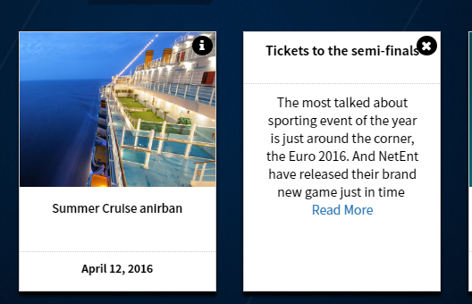

**21.** **Update footer(DONE)**

- Update footer please. (check another excel doc file)

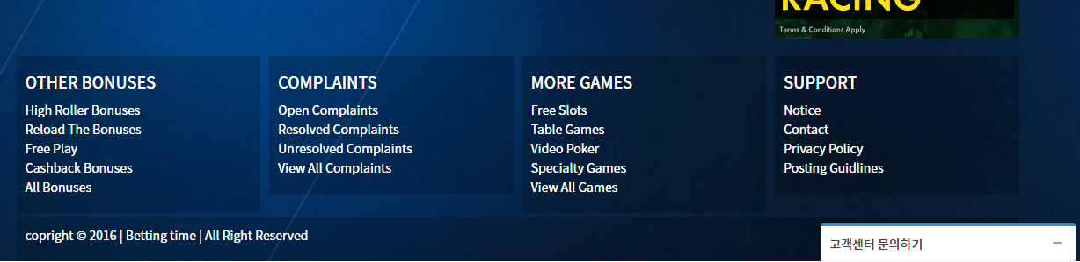

**22.** **Complain detail page.(DONE)**

- Icons are not arrange. please arrange and make it exactly middle side. and please change admin icon. it seems … strange.

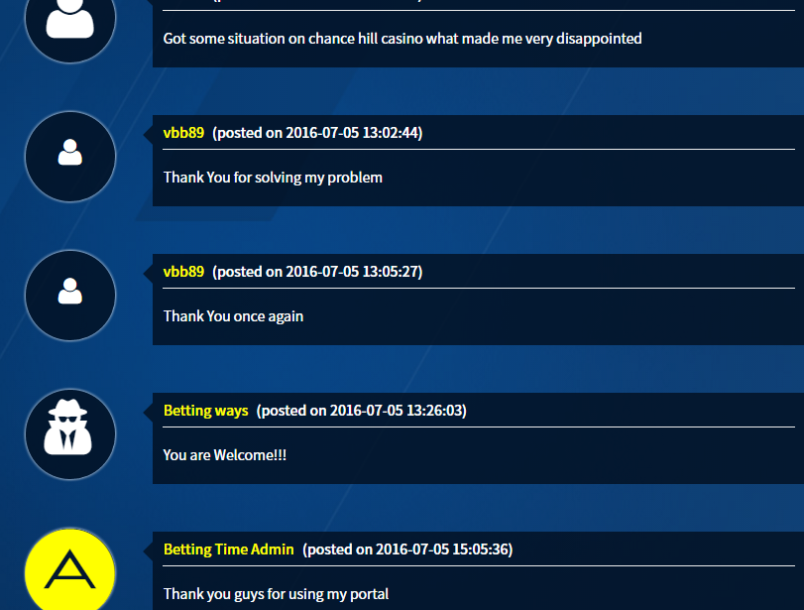

**23.** **Laptop login UI issue.**

- From my laptop, i tried to click register and i cliked sign in and after that i re-clicked sign up again and it happened like below. i can not close this ui. because even i click outside, i can not close it.

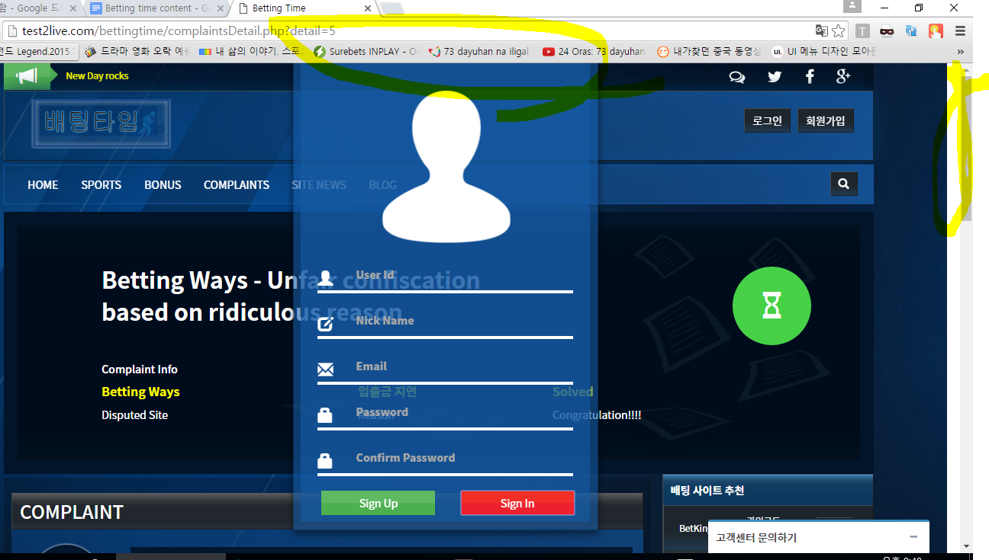

**24.** **SITE NEWS.**

- Please modify like second card for others. other “read more” buttons are seems **very down.** and when content is long , then put “ … “ please. for example , if explain from second card, **“ they’re…**” like this.

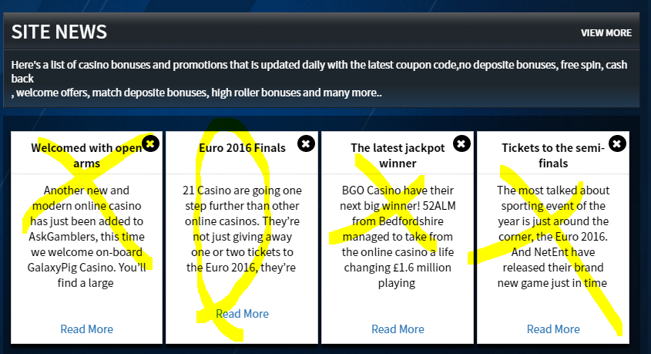

25. **Bonus code read more button.**

- READ MORE button seems smaller than others. please make it bigger .

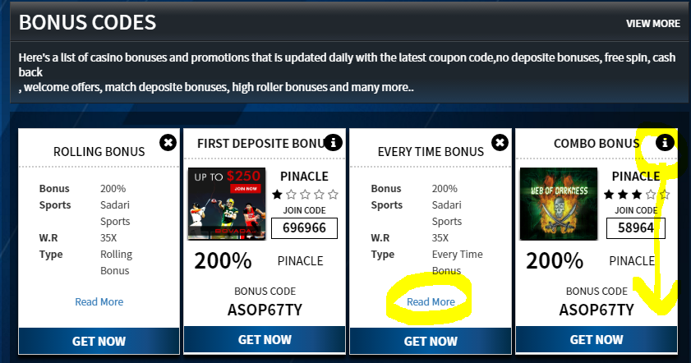

**26. RATE ERROR(DONE)**

- It still same like below. i checked from blog detail page. i think you need to check all pages.

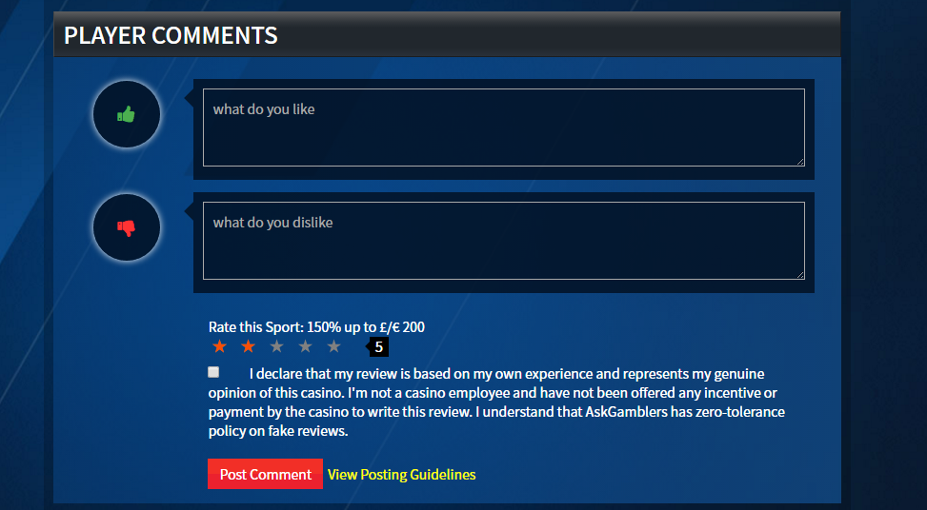

**Arrenge button.**

- seems not correct that x card. and for contents, please put … in the last.

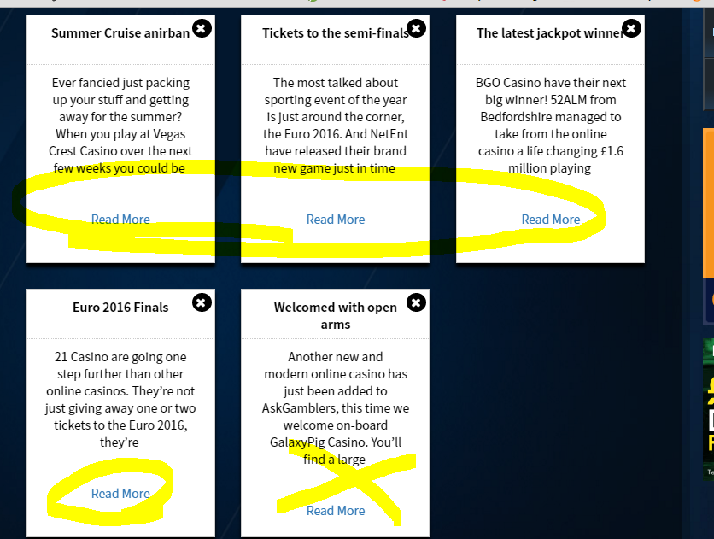

**MAKE IT CENTER THE ADMIN ICON.(DONE)**

- Please make it center admin icon.

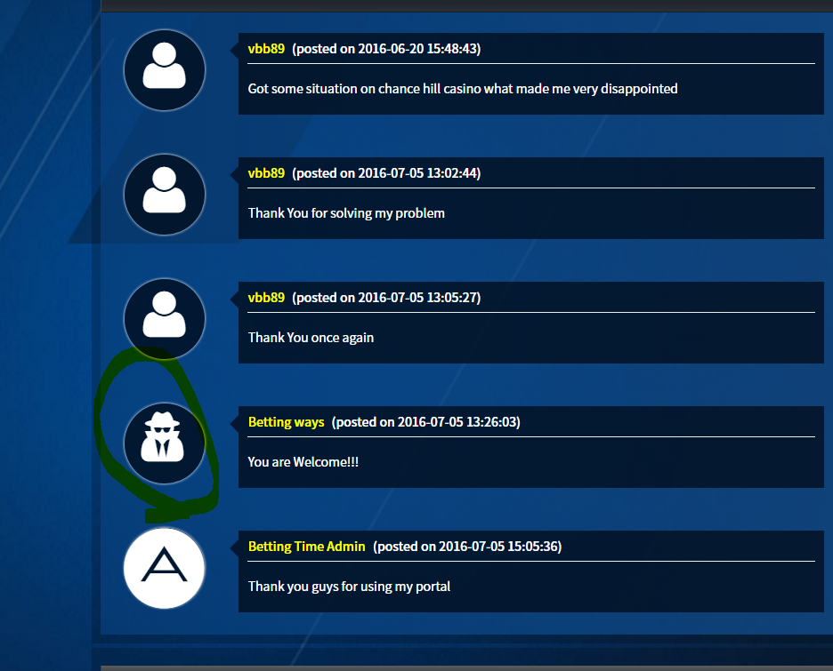

**27.Footer categories.(DONE)**

- From support , below sub categories are new pages.

* [Advertise](http://test2live.com/bettingtime/notice.php)
* [Sports policy](http://test2live.com/bettingtime/contact.php)
* [Certificate of Trust](http://test2live.com/bettingtime/)

[29.From Those 3 sub categories, i would like to](http://test2live.com/bettingtime/) use editor . so i can just post anything. those pages will be like blog or sports news. i mean only one page.

if you are not sure, you can discuss with me before adding new pages.

**Complaints sub categories.**

- Currently, there are 4 sub categories but please add 3 mores. so total 7.

please check excel doc . 3 pages will be payment issues, bonus issues, other issues.

**sub categories filter function.**

- We have not discussed yet about this. we need to solve this issue. (DONE)

**30.IF click logo, please make like going back to main page.(DONE)**

-

**30. CHANGE TEXT FOR THIS .(DONE)**

- thanks for adding this but that test is wrong. It must be like “ **가입코드: 789456 ”**

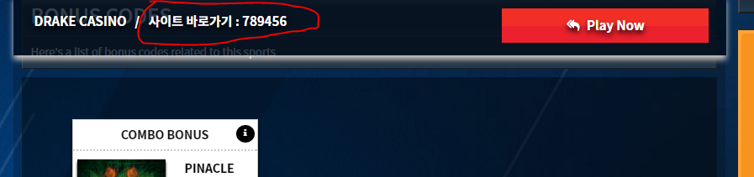

**31. Comment section(DONE)**

- When leave comment without login, it goes back to main page and showing this message but it’s better to show this text from that page not from main page. and it must be failed not “ success! “.

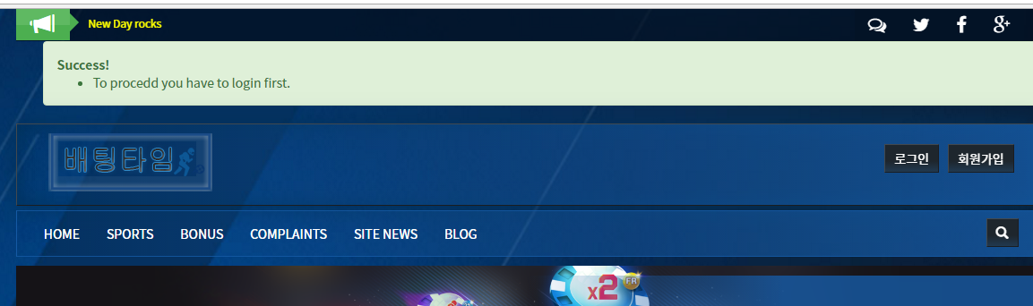

**32. BONUS CODES - read more button.(DONE)**

- Read more button from bonus codes, it seems smaller than others. please make it bigger.

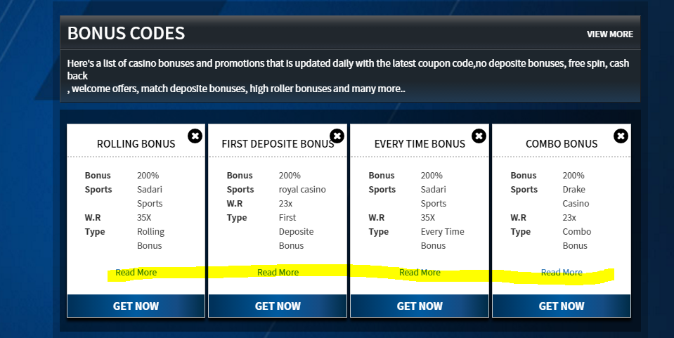

**33. SADARI - read more button.(DONE)**

- Read more button from SADARI, it seems lower than others. please make it up. like above cards.

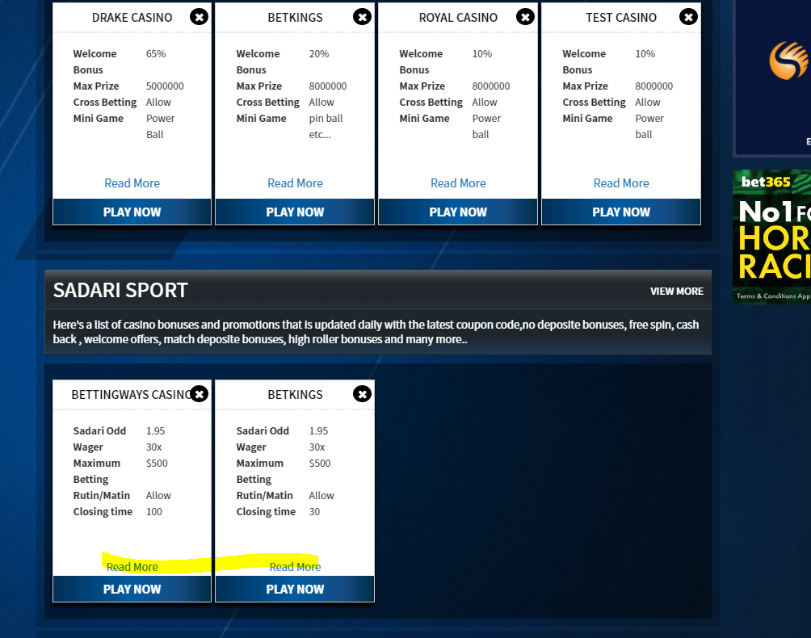

**34. Maximum title lines.**

- When title is long, if it is over than 3 lines, please make it “ … “ . not becoming 4 lines.

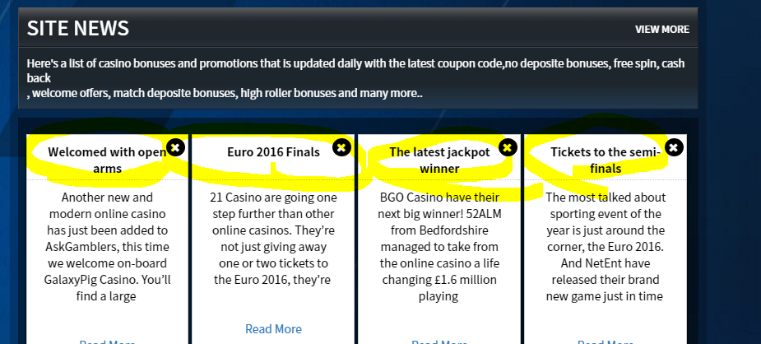

**35. Detail page filter.**

- From every detail page, please add filter .

**36. News - read more button .**

- ONE

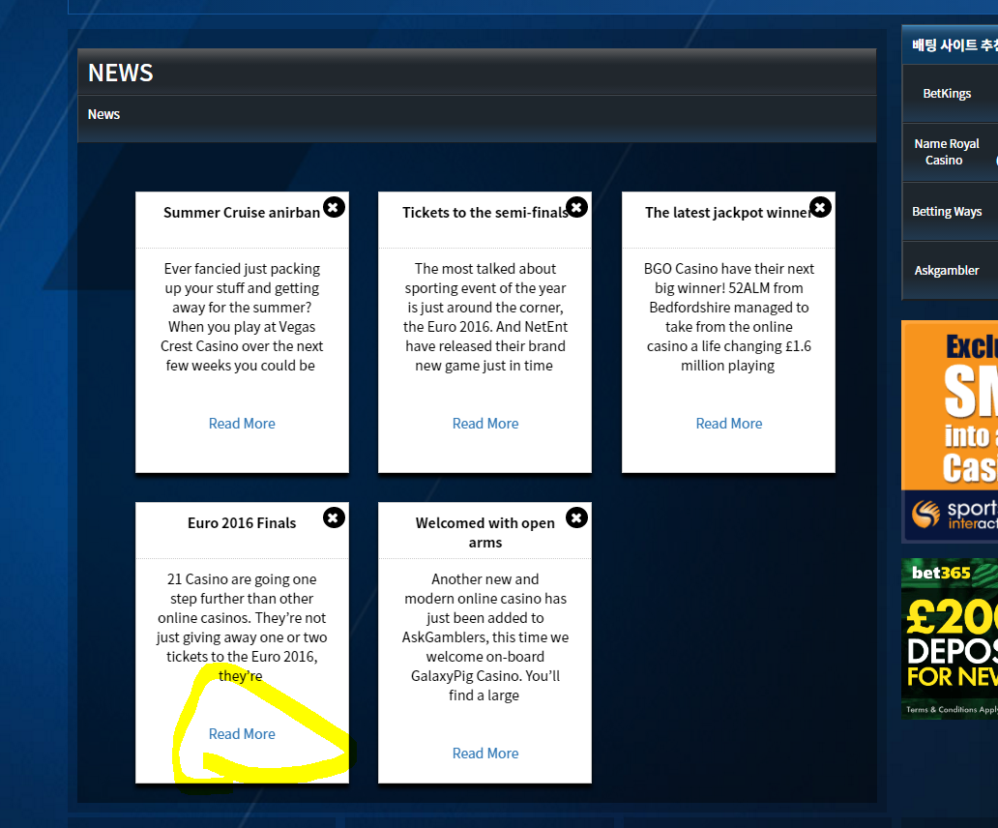

**37. Register UI(DONE)**

- move to left the sign up button please. to make it same line with left side.

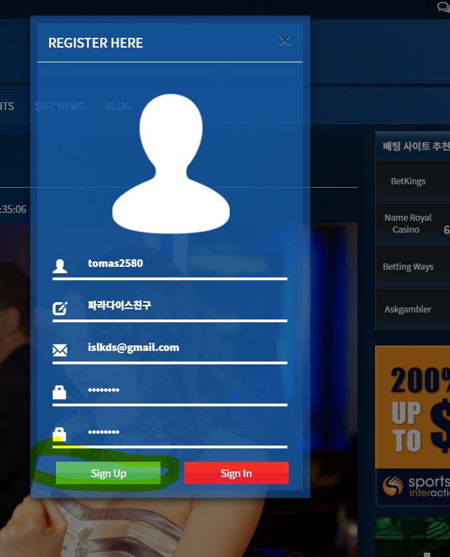

**38. After register**

- After register, there is no any informaiton text or pop-up. So please show pop-up message like “ your account has been created succssfully. You will verify by administor.” After i verify them, i will send e-mails directly or may be not.

**39. Double security.**

- I told this before regarding double security. There are so many hackers , espcially in korea so i would like to do double security. i was thinking about this and when i type password, i better to type with screen keyboard which is typing by mouse not keyboard. and type one more with different second password. If you have better idea, it will be nice to hear.

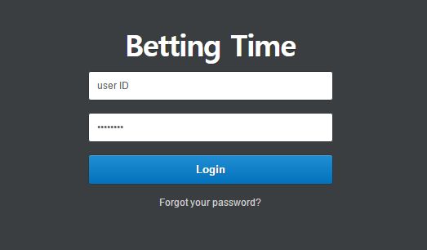

**40. Alarm (after login)**

- When there are new notifications, i dont want to show like that. I would like to show from outside notification, beside bell and showing numbers. maybe on red color. OR “ showing “N’”. if it is like that, nobody can not know there is alarm or not until check like that. AND if click one of that button, nothing happens at the moment. kindly please check that.

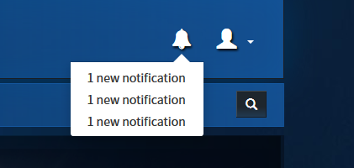

**41. When leave comment..(DONE)**

- When leave comment, must click the check box before click post comment. And after leave comment, please show pop-up message for “ **your comment will be verified by admin. after that, it will displayed. “**

**Don’t forget that, this happens is after login. if not login, must show differnt message pop -up like “ you must login before leave comment. “**

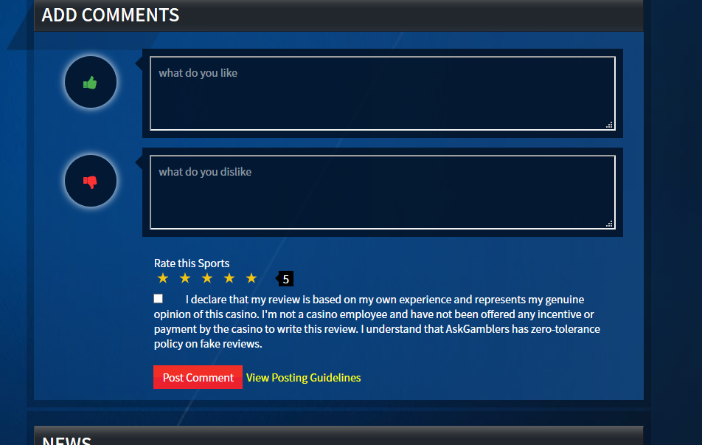

**42. When i login...(DONE)**

- When i login, it showing two message like below. please fix.

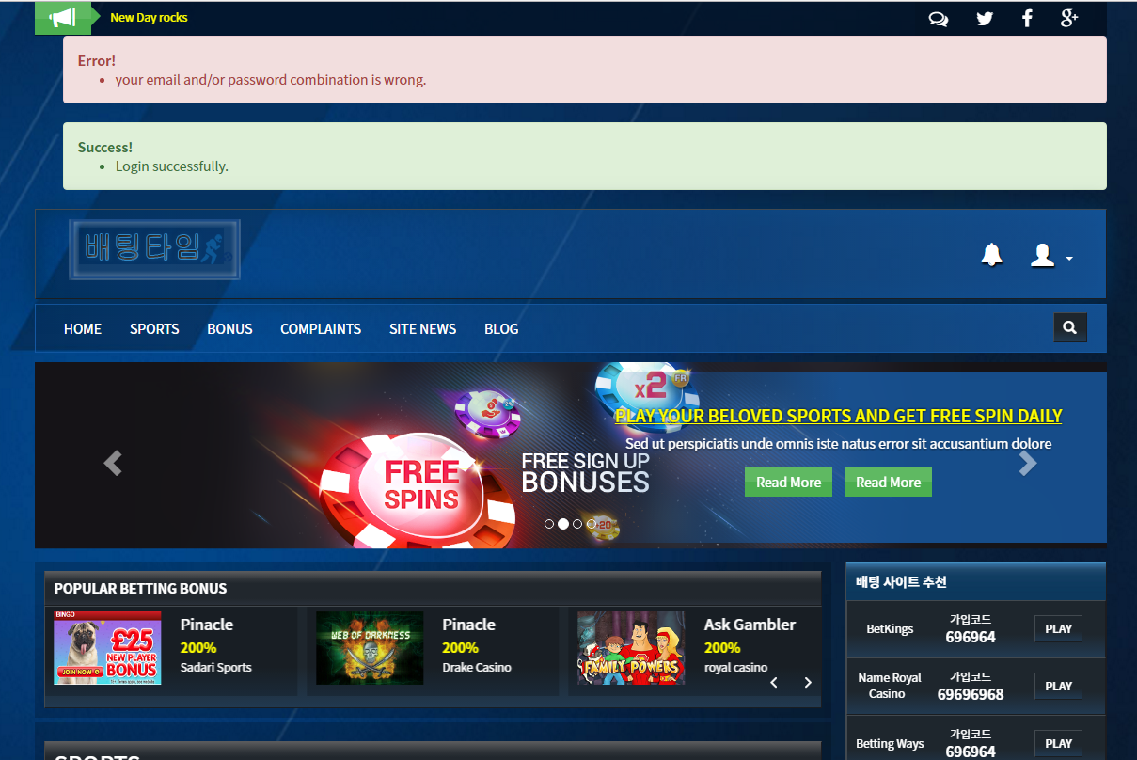

**43. Remove home button please.(DONE)**

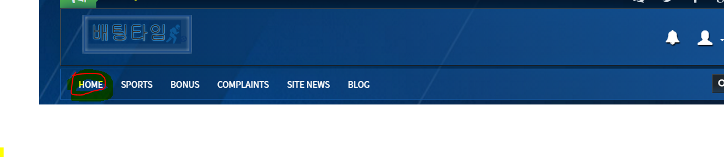

**43. THE CHECK BOX FROM COMMENT(DONE)**

- I can leave comment even i don’t click that check box but it was not updated from admin page. so please make it requisite. nobody can not post comment before clicking that button. so if somebody try to leave comment without that, will show pop-up or message. like” **You must agree with notice.** “ something like that.

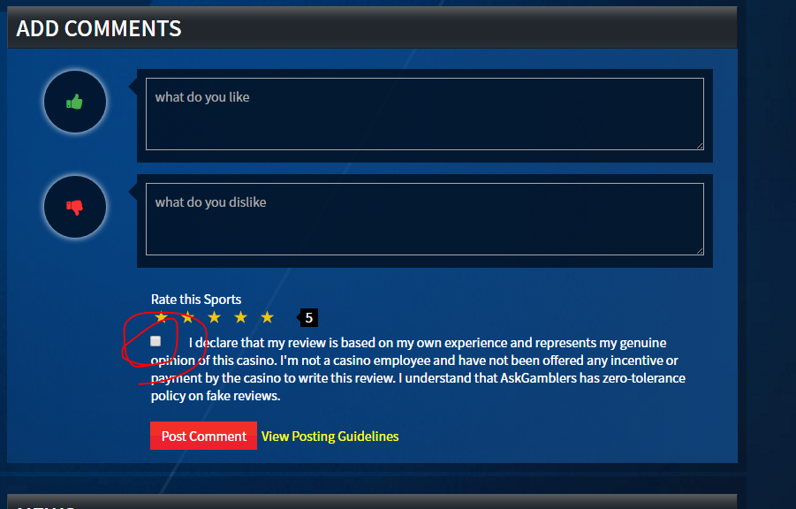

**44. Alarm from admin page.**

- I can not know if there is new comment. so please connect notification module everything..

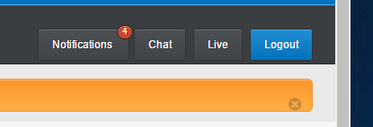

**45. User - admin page(DONE)**

- When i click USER category, it showing from second page. it seems first page but this is error and when i click other pagenation, still clicked the 2. please check .

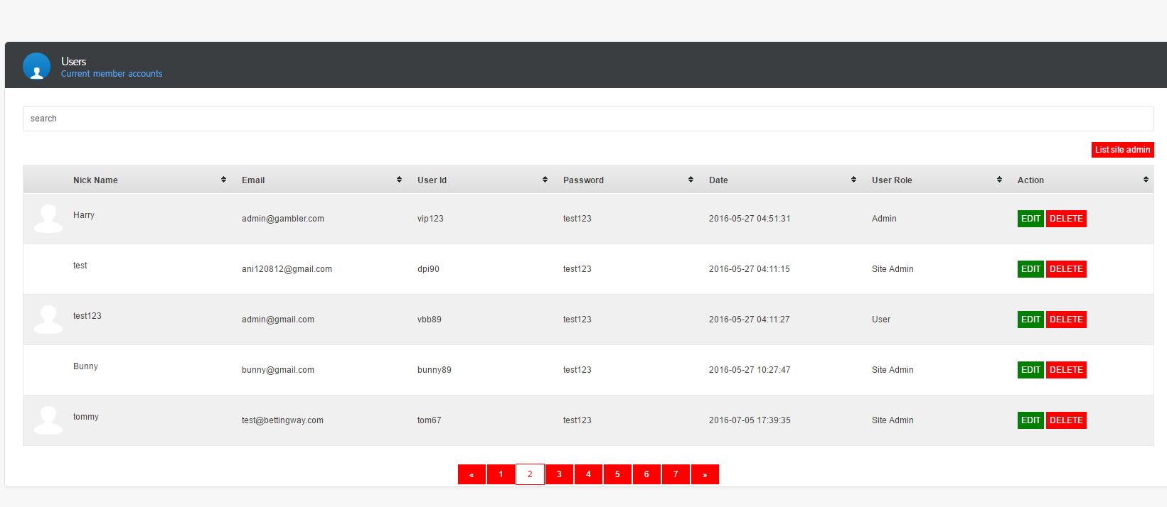

**46. User - admin page / List site admin button / (DONE)**

- When click “ list stie admin “ button, i would like to add back to user button.

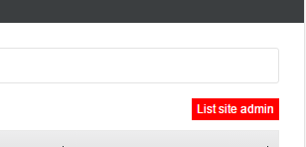

**47. CHAT fucntion**

- Chat function is not working well. kindly please check again.

**48. CATEGORY - DATA(DONE)**

- I can not post from here. even i post somthing, nothing work.

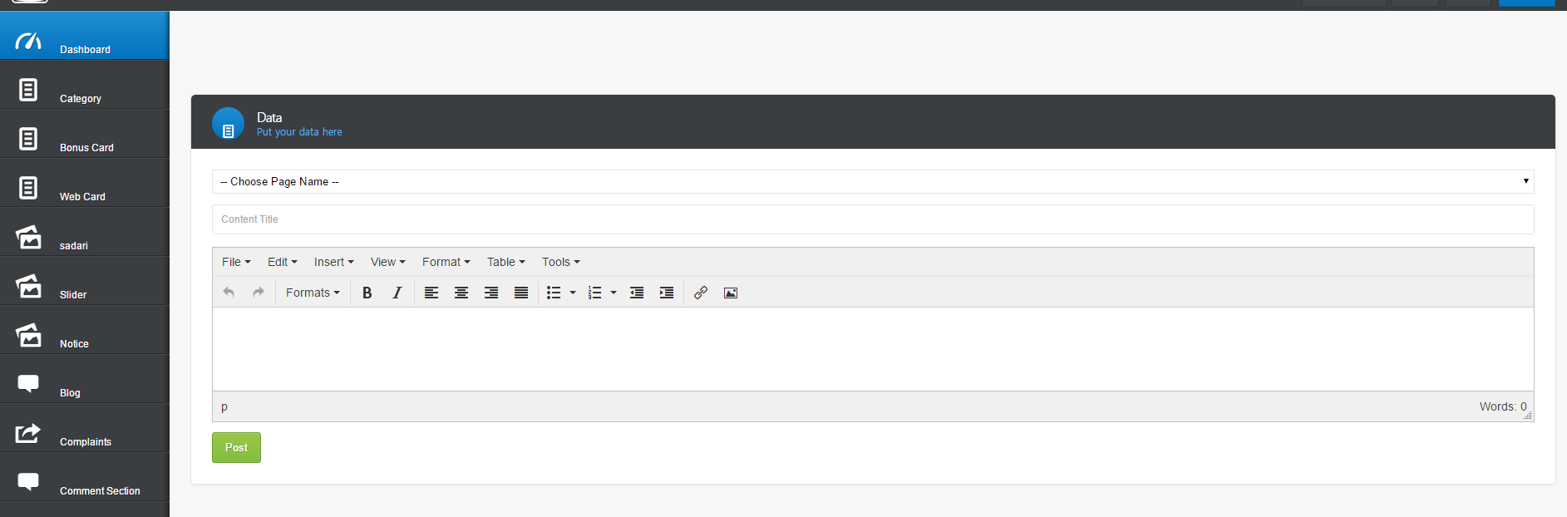

**49. BONUS COAD- additional bonus details error(DONE)**

- If i click “delete last” button when there is only one, i can not add more..

* from Bonus card ,sadari etc check others also please.

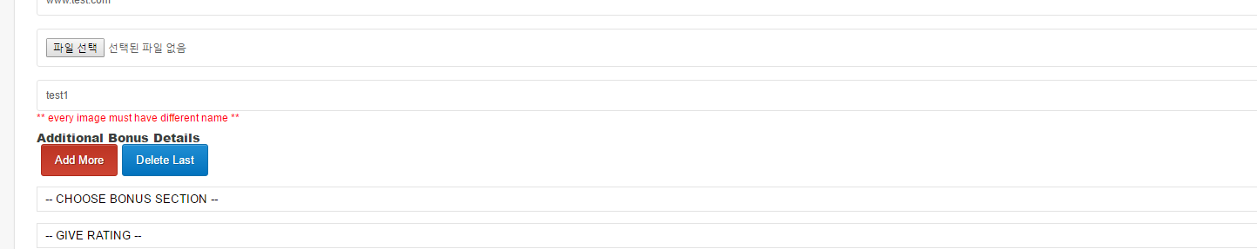

**10-21 update for point 49**

* **Still same. If i click “delete last” button when there is only one, i can not add after again. Same on web card, sadari.**

**50. BONUS COAD- SITE NAME ERROR(DONE)**

- I put differnt name on site name but from website, it updated bonus name and i am confusing with those names. need to change box name.

**51. BONUS COAD- pagenation error**

- Please check all categories. it seems all starting from 2 pagenation.

**Please check all categories pagenation. i think ohers also like that.**

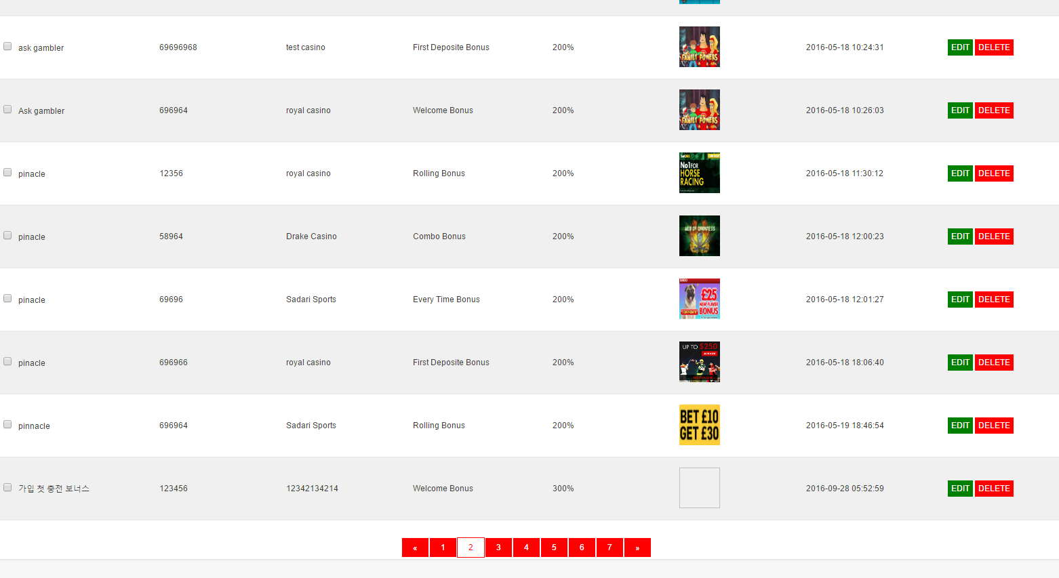

**52. Web card - Additional sports details(DONE)**

- After creating new card and when i click the edit , i can not find that from edit page. i could modify or delete from sports detail but if i can not edit, then i must delete that card. then it could be deleted with user’s comments. that’s not good so please make it editing that also from edit page.



**53. Admin page - Left category(DONE)**

- When i click any categories from left, it still clicked the “ dashboard” so please fix this.

for example, If l click bonus card, then please make it clicked by blue color.

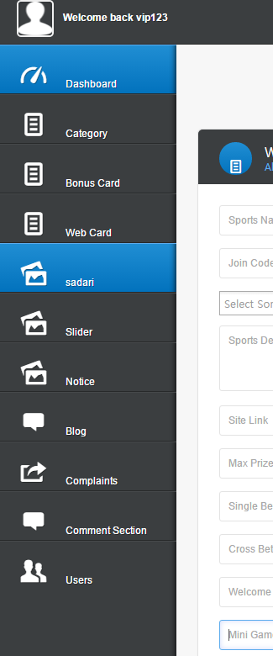

**54. Bonus card issue(DONE)**

- From card image, no.1 will be site name and no.2 wil be bonus name . BUT bonus name will be typed by me manually because as we know, bonus type could be long. So, i will make it shorter myself.

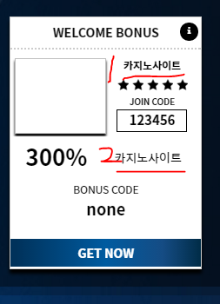

**55. Bonus detail page - pop-up(DONE)**

- From bonus detail page, when i scroll down, the red circle must be site name. but now, that is bonus code so please modify it to sport name.

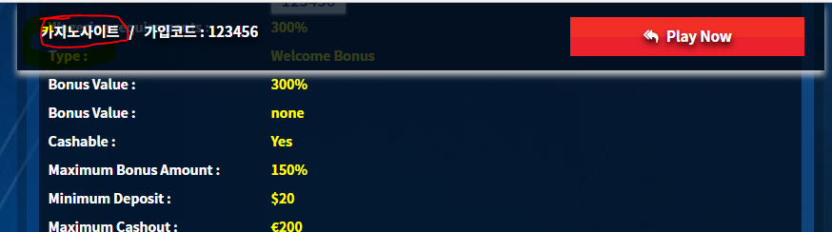

**56. Slider**

- After creating new slider and if i try to edit , it showing like below. So i can not edit actually. and if i don’t upload a image, it is broken from website. And there are 5 sliders but slider numbers are only 4 . it seems fixedable. (it must be 5.)

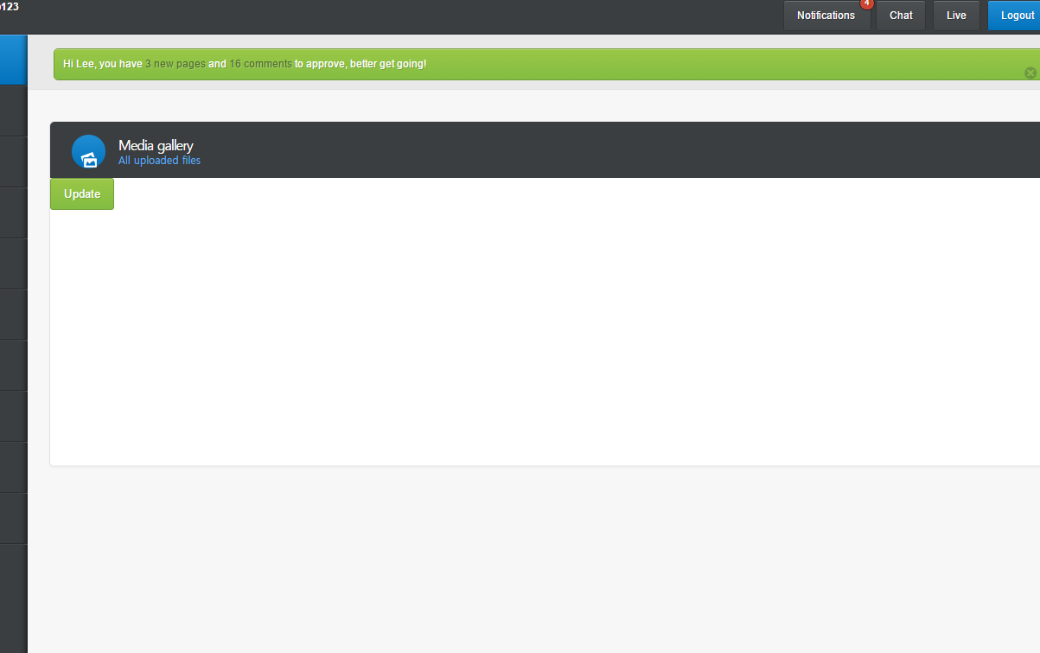

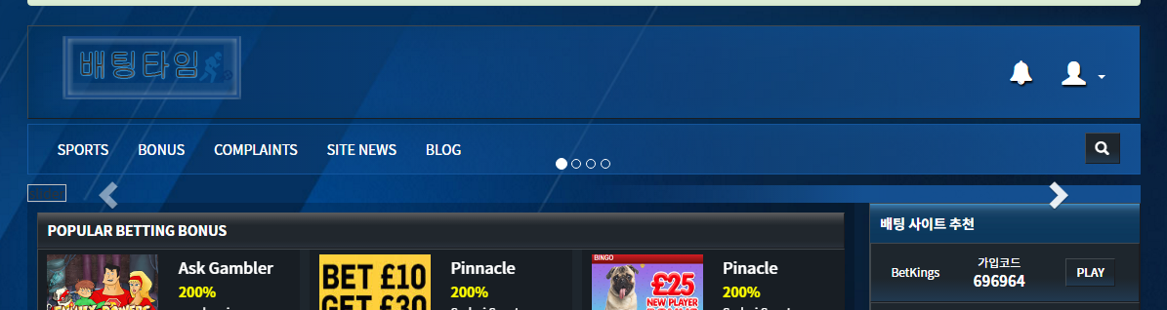

**56. Notice category(DONE)**

- I forgot to ask you creat notice category on navigation bar. please add notice category on last to go directly.

**57. Notice - button error(DONE)**

- When i pin a notice, the button changed like that. please fix the error.

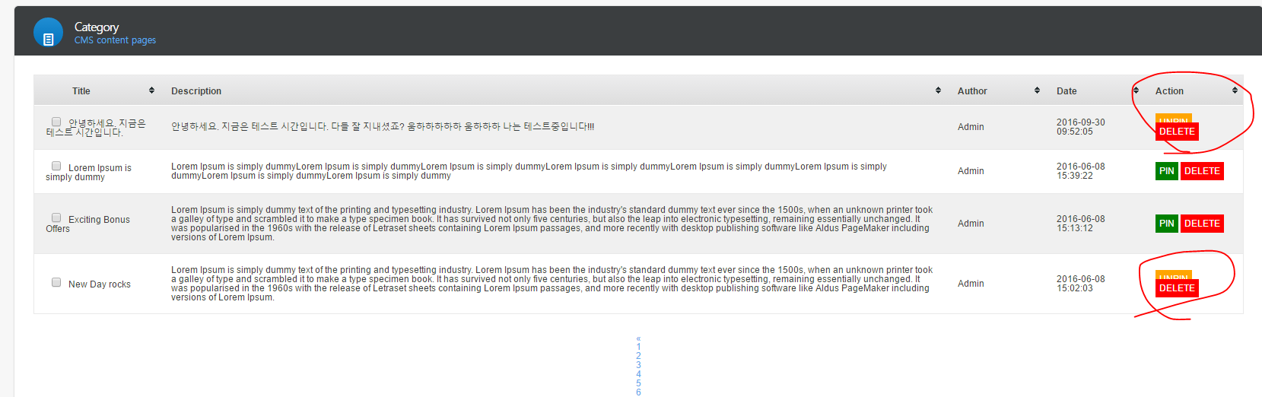

**58. All editors(DONE)**

- Please modify width to fit below content box from admin page editor. so i can write contents well by correct lines.

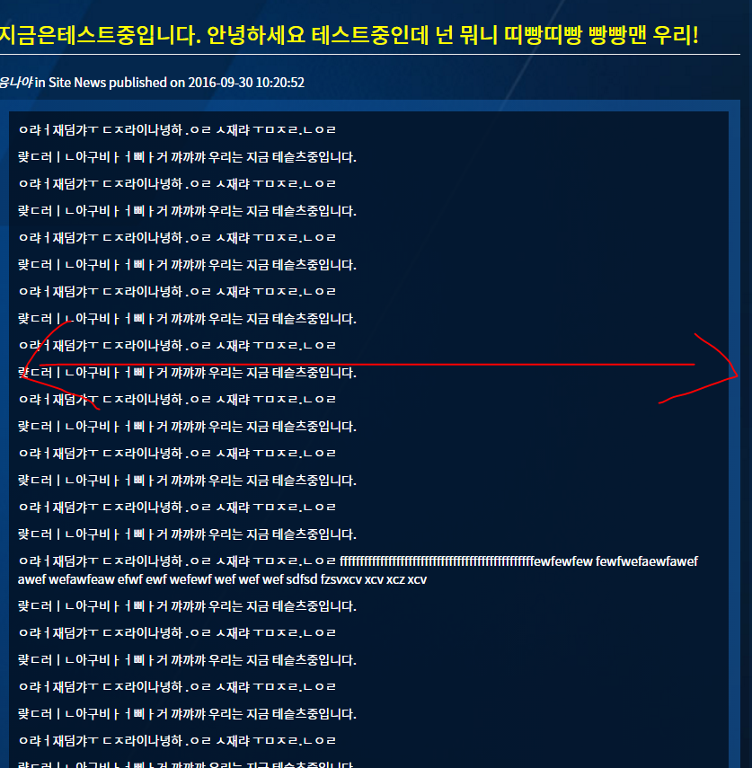

**59. Admin page - comment section (showing leaving time)(DONE)**

- As i know, all of comments must be verified by me. i think if there is time when user left the comment, it will be more nice.

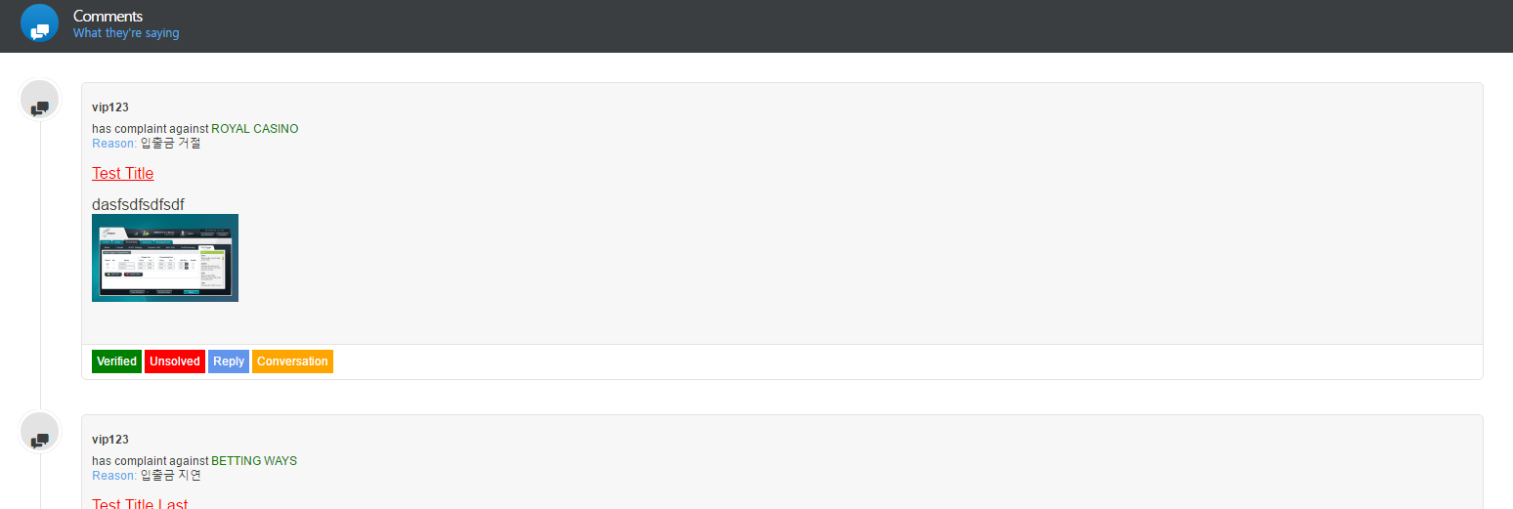

**60. Admin page - comment section - News comments > News&Blog comments.(DONE)**

- Please change name the news comments to News&Blog comments to know this section is for both . not only for news.

**61. After leaving new comment…(DONE)**

- When users leave new comment, please show pop-up or any info text regarding verify.. for example, after leaving comment, text box will displayed like “ **Your comment will be displayed after verify.”** because user could confuse what is the problem with leaving comment.

**62. Comment section error.(DONE)**

- When i scroll from comment section, it showing the error like below. top header and below pagenation. please fix. And pagenation button seems like too small. so make it more bigger please. For last, please check “more” button . it seems not working.

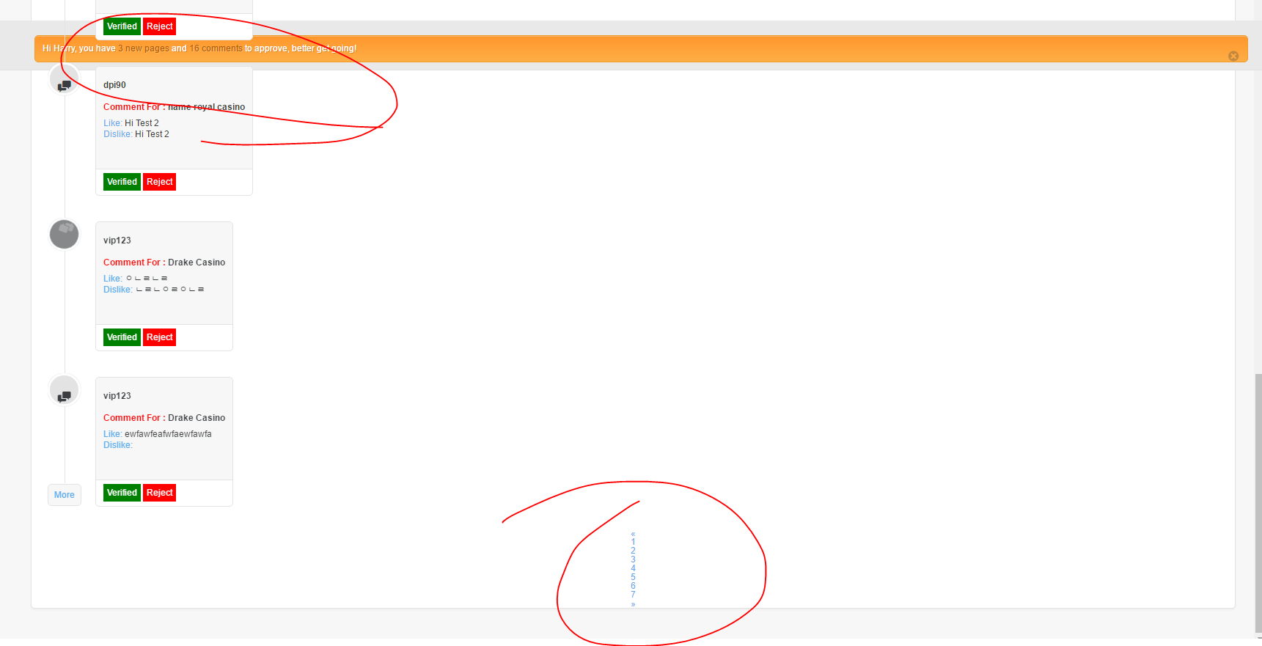

**63. Comment section (Verified comments will be under unverified comments)**

- I would like to see unverified comments on the top always. So for example, if i verified any of comment, that comment will be went to under unverified comment. So when there are lots comments, i can handle easily. And Newst comment will be on the top always. so oldest comment will be going down. (Including new comment from conversation)

* **Complaint section also please.**

**64. Complaint error ? This is due to wrong entry it happens for one time cause i driectly added few data in database**

- From Complaint, from first comment, when you click conversation, and below, there is something error like below image. kindly please check.

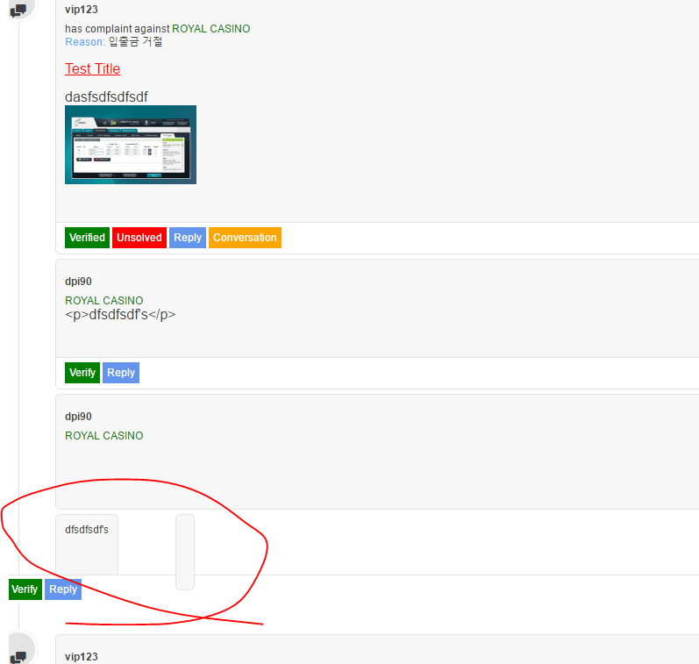

**65. admin page - main board.**

- I am not sure it will be updated later but i just leave here for sure. website figures and timelines are not updated to real number. the reason why it is like that due to not connected, then just ignore this please.

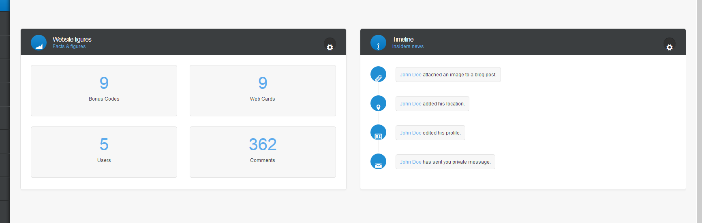

**66. admin page - LIVE button.(DONE)**

- When i click Live button, Error and success message showing together like below image. is it normal? if it is not, i would like to hide those two.

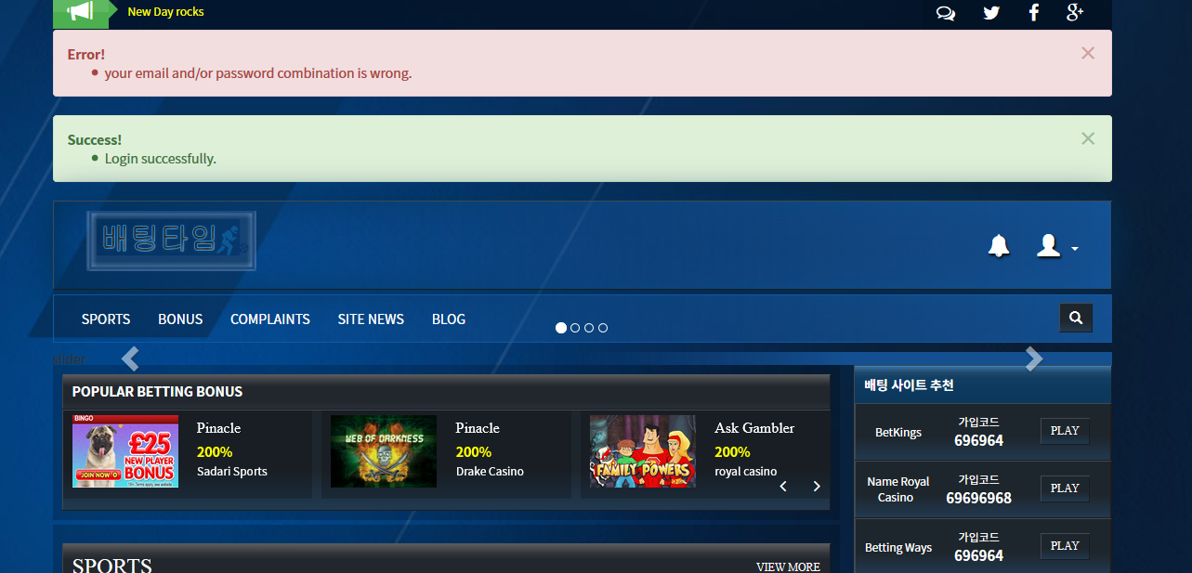

**67. Submit complaint - After select an option.(DONE)**

- when i try to make new complaint, site name was showing like below. please fix to see.

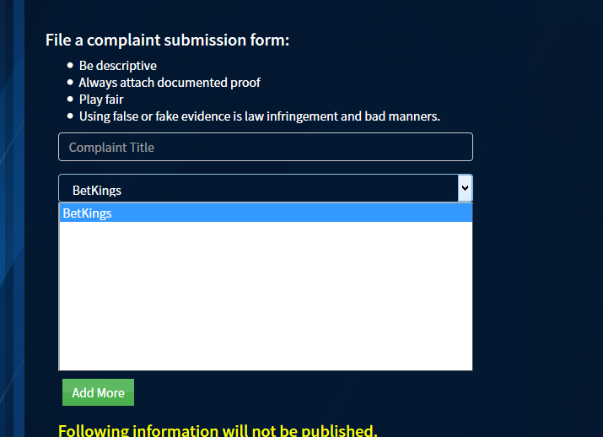

**67. Submit complaint - user sport site id.**

- Only need one filed , first one and this user sport site ID will be displayed on page and only me and site admin able to see this ID. So, If other users open the page, then it will be hided.

* And “Terms and Conditions” page was not connected. let’s talk later regarding this. Also If didnt click the check box, please show below text message.

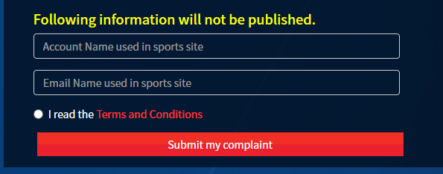

**68. Submit complaint - After select an option.**

- Please put below 2 korean info text boxs on below that Amount filed. because always put currency after number so i need to explain about that.

* 금액을 입력해주실 때 만원 단위로 숫자 표기 해주세요. EX.) 1,000,000원 > 100
* 해당 글이 올라갈 때는 숫자 뒤에 "만원" 이 붙습니다.

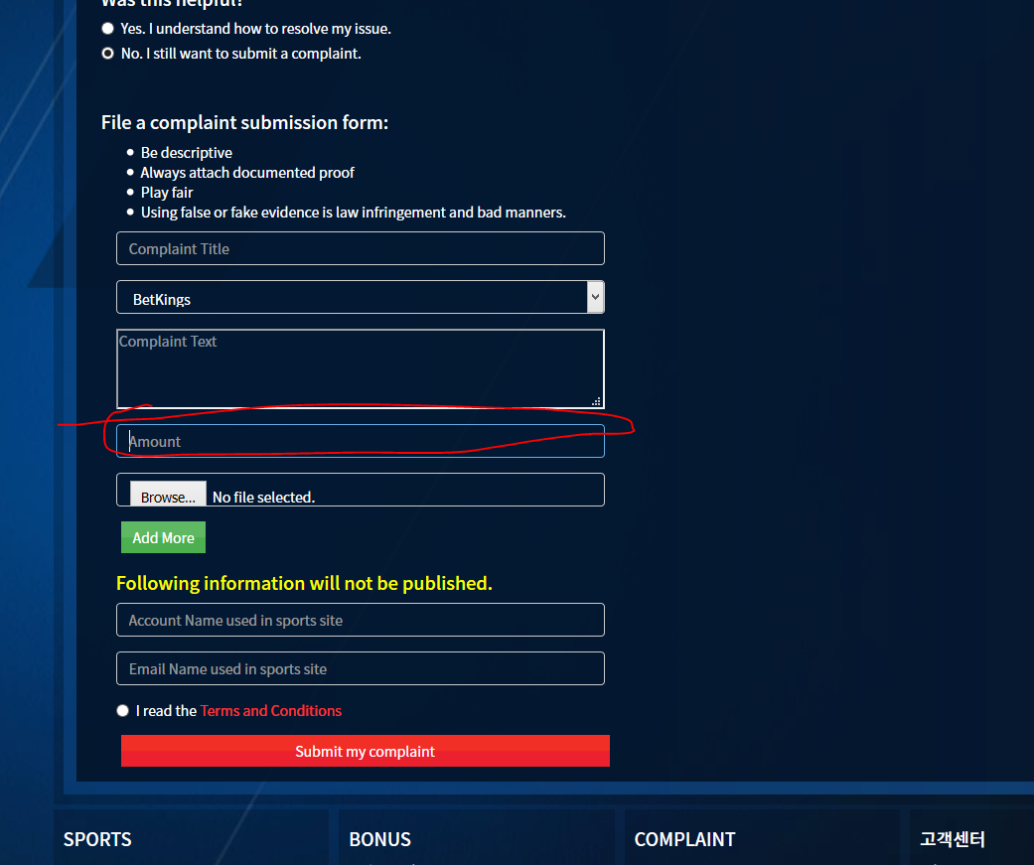

**69. Sports - Join code.**

- From Bonus detail page, i can see Join code box like that but from sport detail page, it is not showing like that so please modify like that too on sport page please.

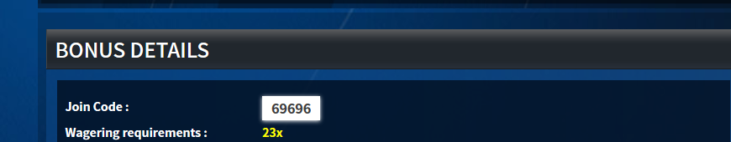

**70. Sports - Join code.**

- From Bonus detail page, i can see Join code box like that but from sport detail page, it is not showing like that so please modify like that too on sport page please.

**71. Submit complaint - “Terms and Conditions”**

- Please make new page for this **“Terms and Conditions”** and and this will be hiden page. only able to see when click that button.

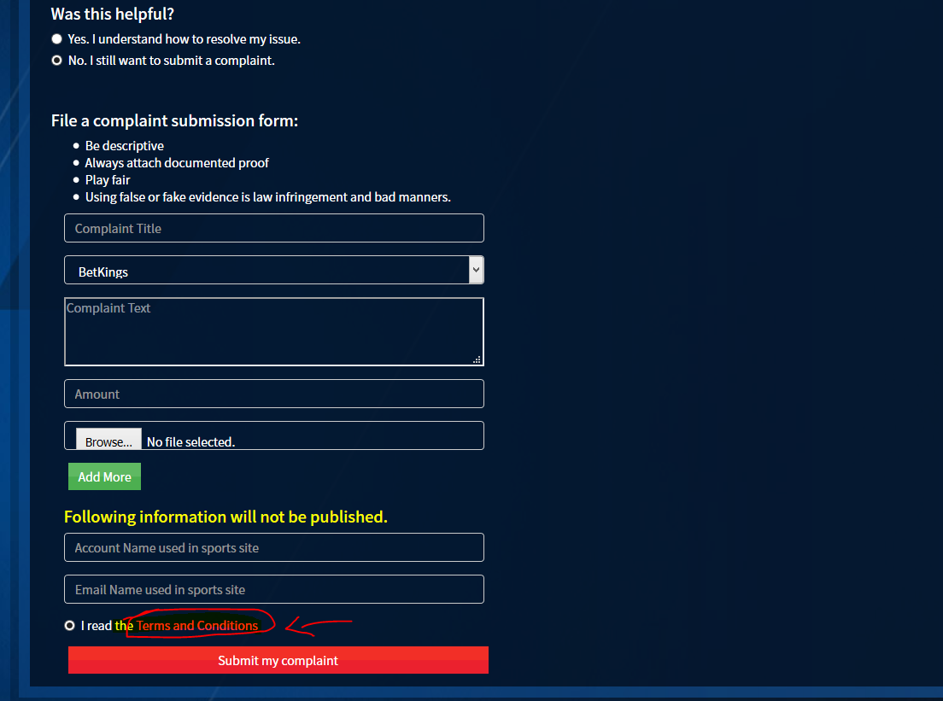

**72. Comment - “Posting guidelines”**

- Please make new page for this **“posting guidelines”** and this will be hiden page. only able to see when click that button.

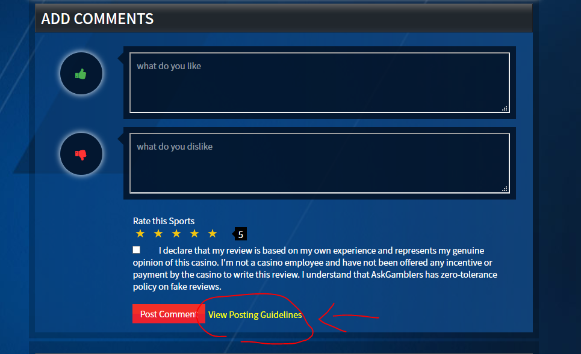

**73. Currency error**

- From complaint detail page, when i checked other complaints, it was showing different currency. please fix .

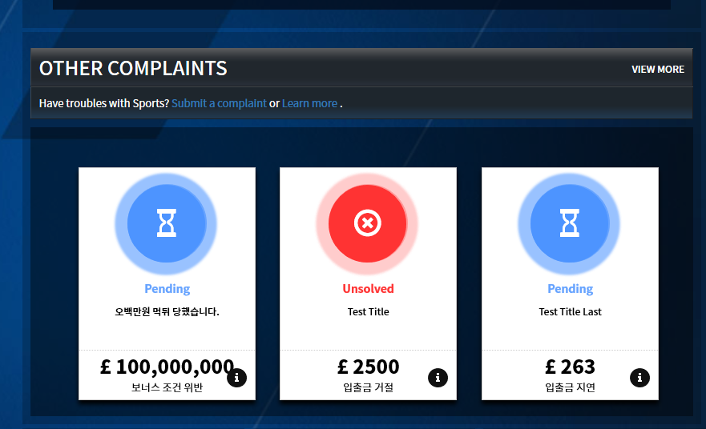

**74. Card error**

- Even there is no reason to error but center card has been became strange. please fix.

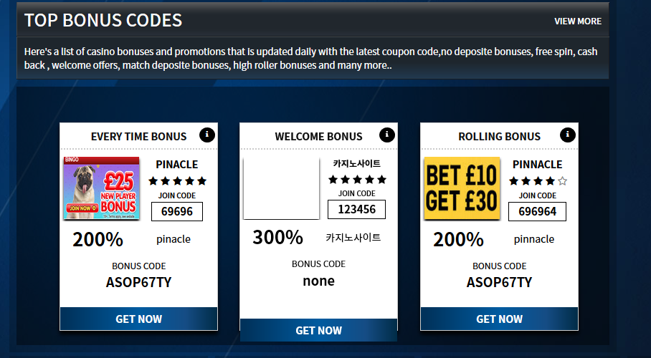

**75. Bonus card error - I can not create more cards!**

- I can not test because not able to create bonus card anymore from admin card. Please check as soon as possible and fix it to continue test. Also , popular bonus option is seems not working. please check too.

**76. Slider error**

- When i added new slider, it showed like that. i didnt upload a image but even i didnt upload a image, i would like to show even only text.

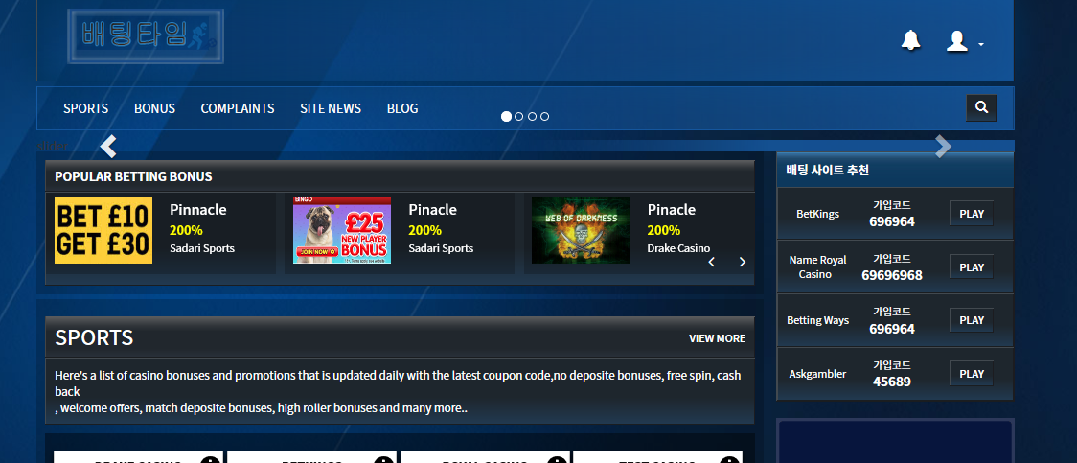

**77. Category - admin page**

- When i make long content like below image, it showing all. But i would like to make “shore more “ button like askgamblers. I think we talked about it before. So when you are going to do this , please give me skype.

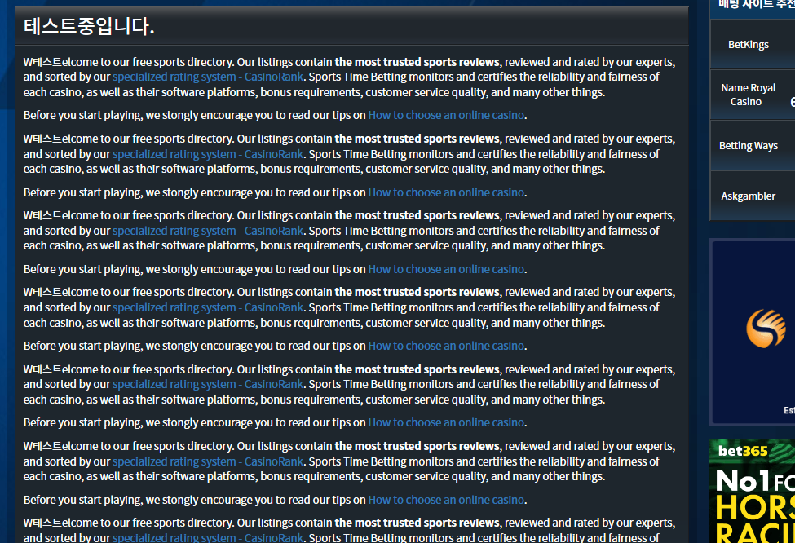

**77. Admin page - Bonus,sadari and sports just all cards. “label issue”**

- When i click edit button, i can not edit labels. So please make it editable labels.

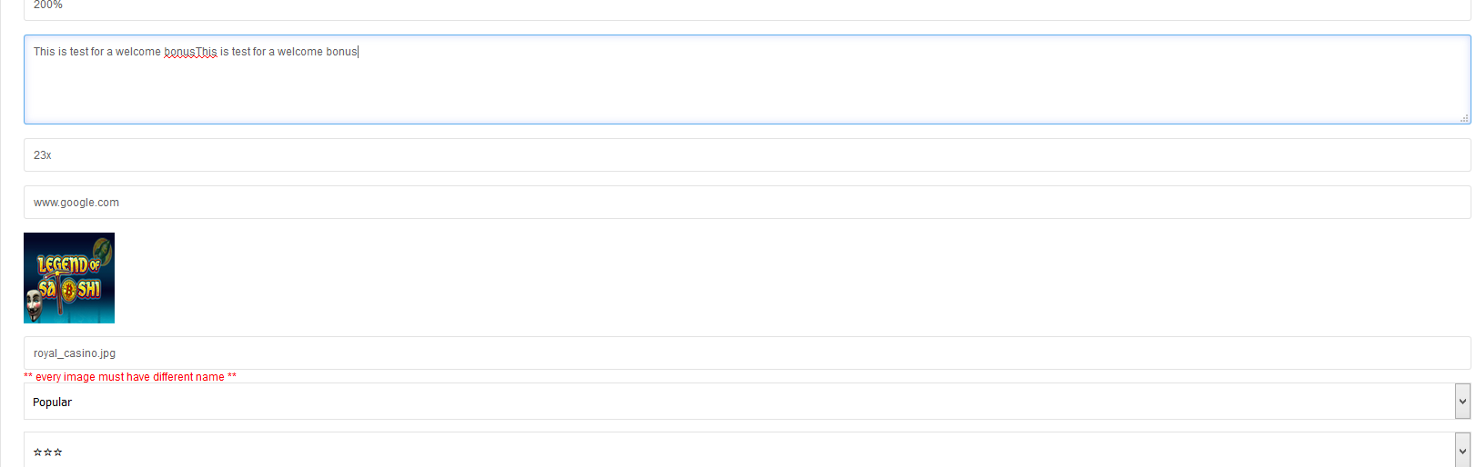

**78. Admin page - All card edit page**

- When i edit, i can not change image and category. **Please, Make all editable**. .

**79. Pagenation error from all list page from website.**

- It is not generated pagenation numbers like below from all list page. Please check all again.

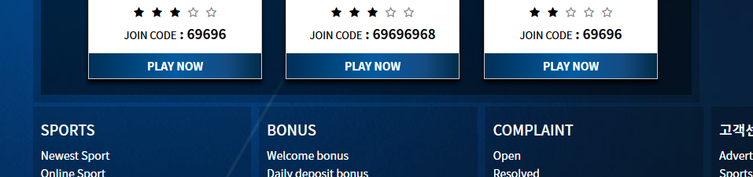

**80. Stay 9 cards.**

- If we are going to add “show more” button on title content, and if we even open the content, I would like to show all . not just showing only few.

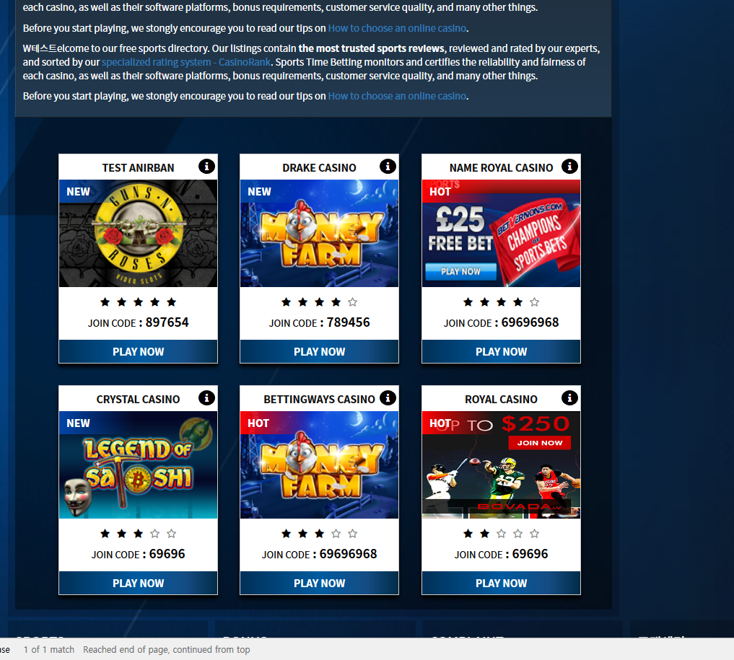

**81. joincode error (It is also showing “o” from card)**

- Join code could be word. not only numbers. when i put korean word, it kept showing 0. please fix.

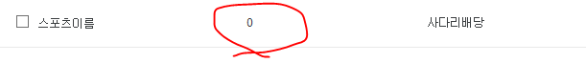

**82. SADARI SPORT CARD ERROR**

- Card error like below image. there is no reason i think.

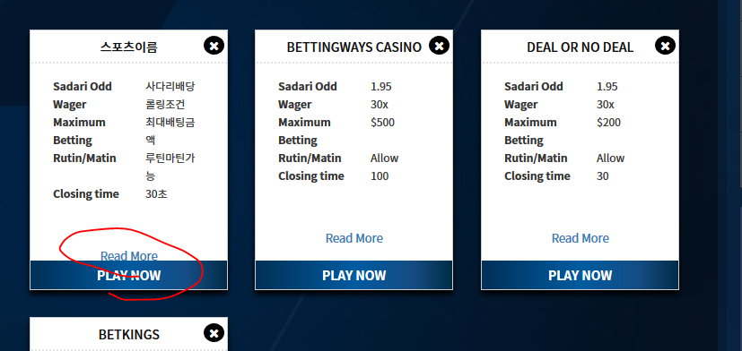

**83. Sadari sport card error**

- When i click new card, it going to different card detail page..please fix.and when i don’t upload image, it showing like below.

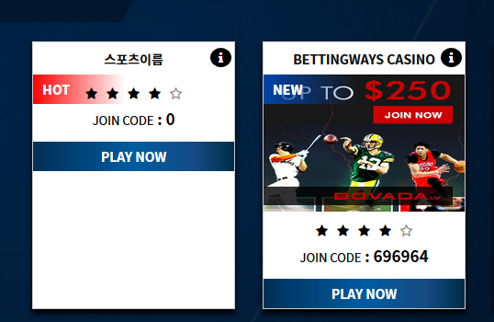

**84. New card error**

- When i add new card, it showing 2 Player reviews Even there is nothing. Please check all again.

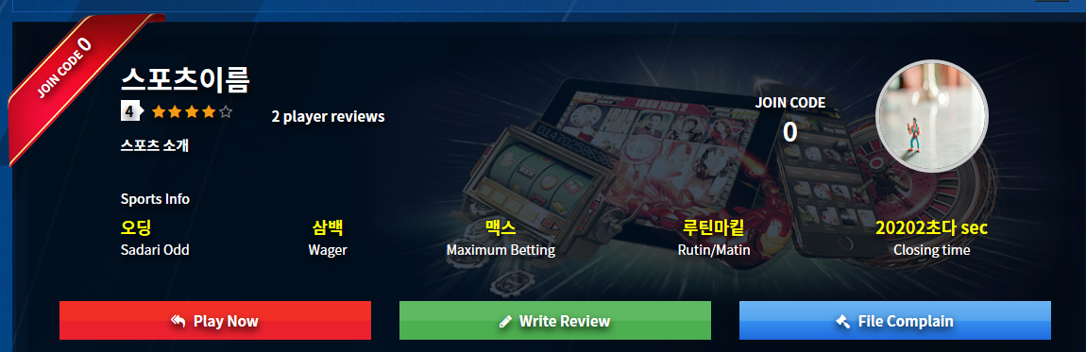

**85. JOIN CODE ERROR**

- I put word on there and it became 0. and that must be under Joincode. please fix.

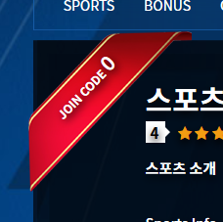

**85. LAVEL ERROR - ALL PAGE**

- When i add new label, it is not updated on detail page. please check all page..

**86. Main page card updated.**

- I can not change or add something like that for main card. it is not updated. please fix.

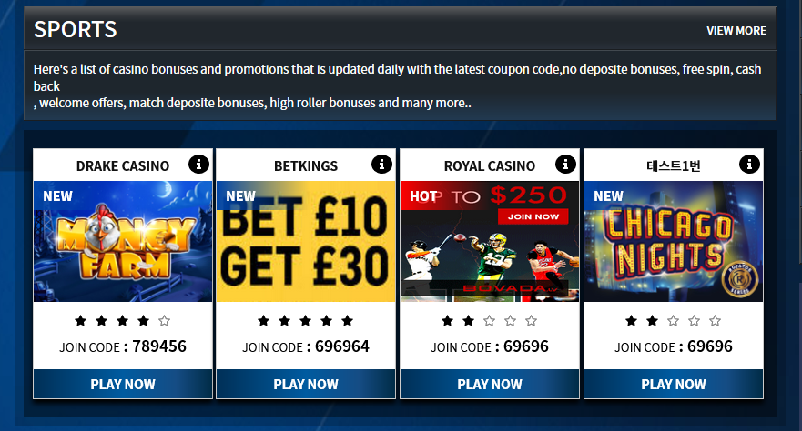.

**87. Getting error when create new web card.**

- When i try to create new card, it showing that error and i can not create anymore anyways. it was not generated.



**88. Slider admin page is not working.**

- When i try to create new slider, it is not working and not updated. please check.

**89. COMMENT- BONUS**

- It is not showing where user commented. please add.

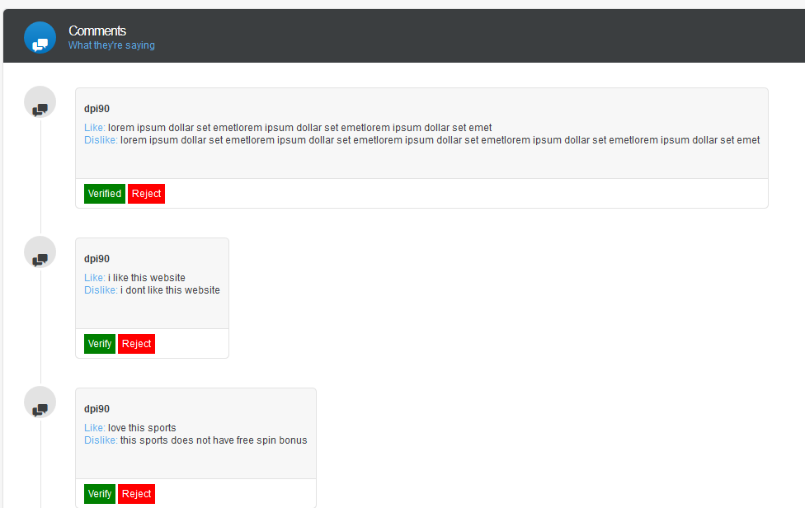

**90. Blog,site news comment error.**

- There is no error message even i dont click the check box when i leave comment. please generate error message to check that box. it must be required. **And please show success message after leave message. it is not showing too.**

**91. There is no any update on news comment from admin page.**

- Even i left comment from site, there is no any comment waiting from admin page. please fix.

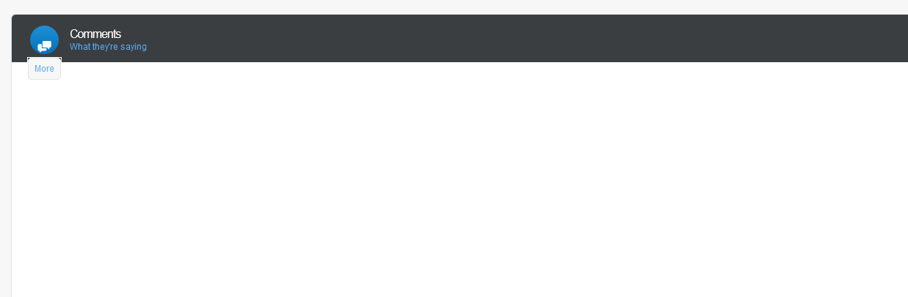

**92. Please fix the pagenation from ALL PAGE (admin pannel)**

- It is showing error pagenation like below. it was same on other page also. please check ALL.

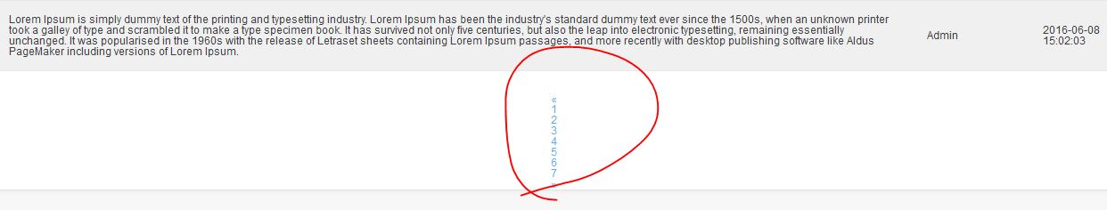

**93. Complaint comment box text color (change to white)**

- IT is so darkness at the moment. please change it to white like other comment box text color.

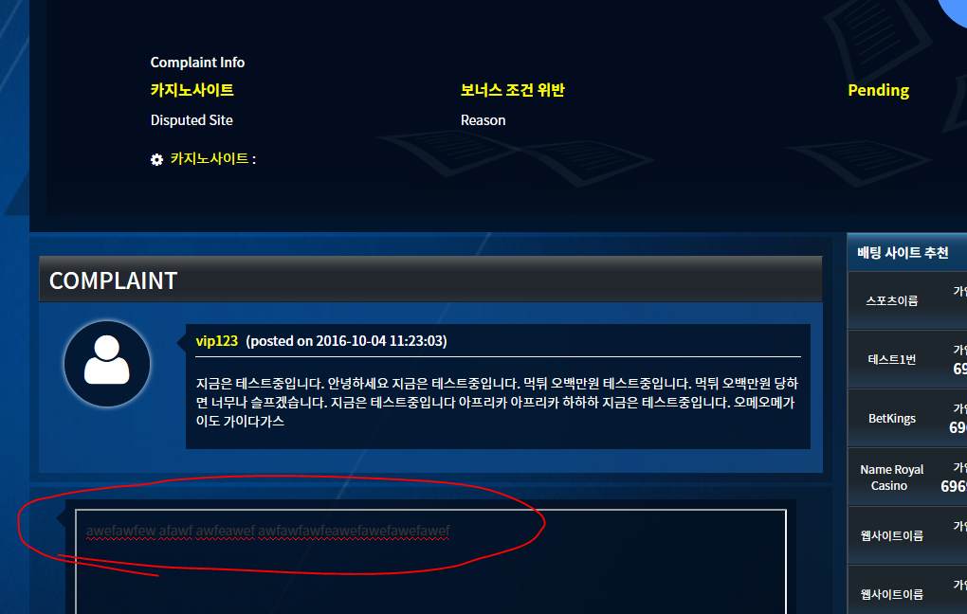

**94. Label error**

- When i add new label, it showing like below. please fix. (I tested with korean language)

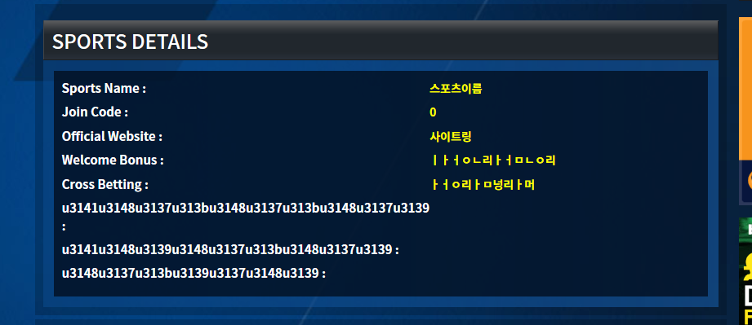

**95. Submit complaint - comment error.**

- As i heard, even i leave comment on users complaint , i can not leave.

**96. Admin page - complaint reply error**

- Even i reply comment , it is not updated from website. please fix.

**97. COMPLAINT - more bigger title.**

- When i tested with korean language for title, it seems very small. please make it bigger.

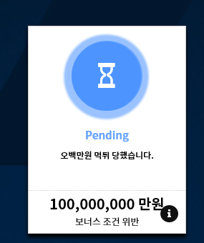

**98. Complaint - conversation**

- when user and site admin talk, one of them could need to upload a image. So please update it if it was not possible uploading a image while talking.

**99. Regarding filter**

* For example, There is A filter for bonus and This A filter is for only few sub-categories. then This A filter is showing from only where i added on sub-categories?
* Ex, “Minimum Deposit “ filter. i put this data on only “First deposit bonus” sub category. Then, when i click minium deposit filter from first deposit bonus page, then it must showing data right? BUT my question is, if i go to different sub-category page, that data also showing even it was not included on that sub-category? hope to know.
* Simply, if i use filter from any sub-category list page, result will be coming from that page list or from all?

**100. Blog & Site news - edit image.**

* After creating new blog or site news, when i edit again, i can not change image. please make it editable everything.

**101. Blog & Site news - Title issue.**

* When title is longer than 2 lines, then please make it “...” on last. as you can see below, there is broken when title is long.

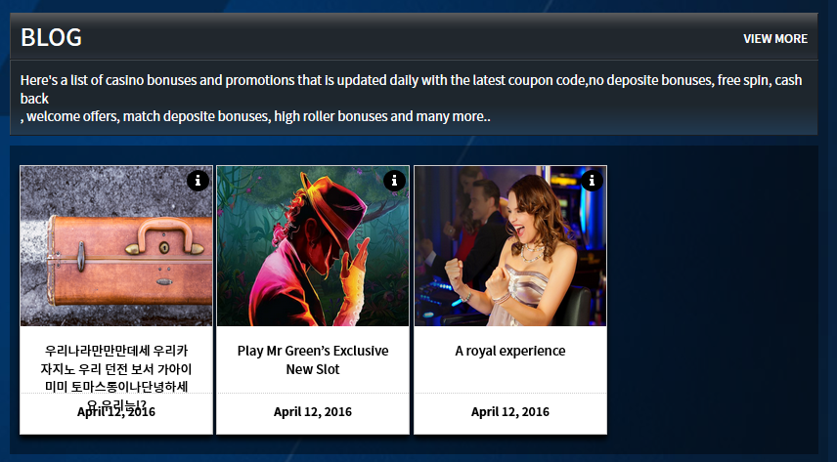

**102. Sadari & Sport & Bonus ALL CARDS - Hided when i add many minigames.**

* When i add many mini games, it is not showing from list. it’s gone somewhere. And i could put more than 8 so even from detail page if there is not enough space from top summary, then please make it “ … “ on the list. and all of mini games will show from below detail box.
* * Make it max letter so it will be automatically generate “ … “ on the last.

**103. All card’s title must be like this below image (by askgamblers)**

* As you can see, when title is long, there is “...” on the last. so all of title must be like that to avoid broken card.

